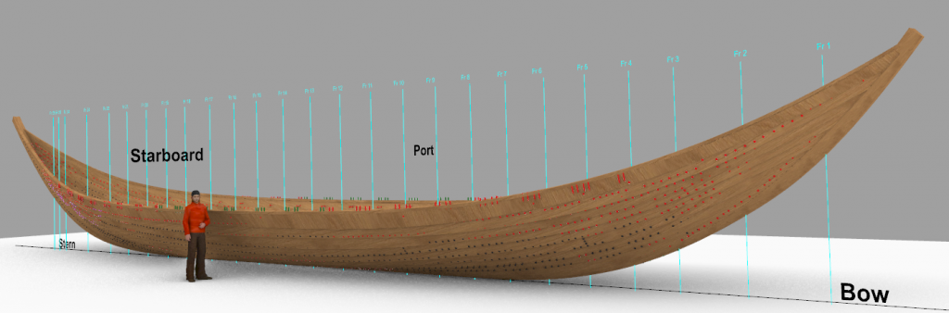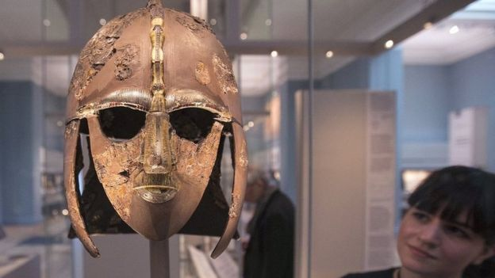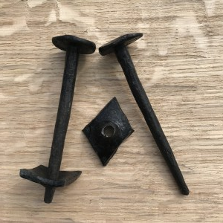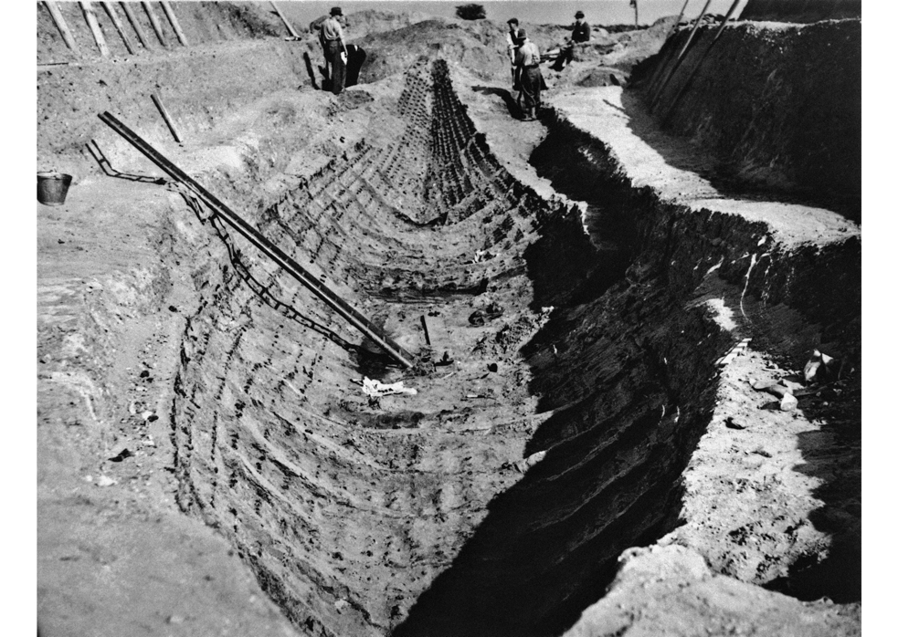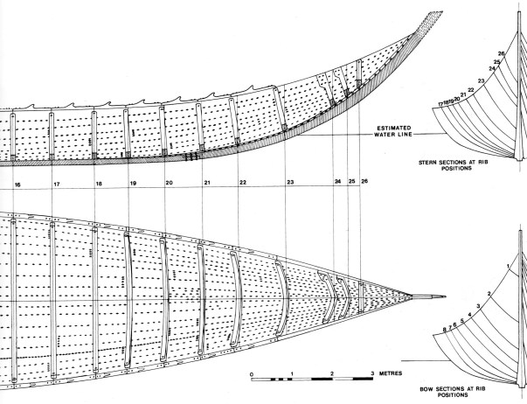

**Why build a replica ship?**

This project will gain new insights into the craftsmanship and seamanship of the Anglo-Saxons as well as their lives, culture and trade between East Anglia and neighbouring countries.

After the build we will carry out sea-trials, to test how the boat was propelled (by oars and/or sail), what it could have been used for, what it may have carried, under what conditions was it safe and therefore where it might have been used.

The final stage of the project will see history re-enacted as the ship is hauled up the hill to Sutton Hoo, just across the river from the Longshed, where it will become part of the National Trust heritage site.

You can see in the picture below how elegant – and how big – our ship is, in this digital image from Southampton University.

**BUILDING AN**

**ANGLO-SAXON SHIP**

**Look, this is a Rivet**

**The Sutton Hoo Ship excavation 1939**

Nothing was left of the ship except the ghost of an impression in the sand and a number of iron rivets which lay in rows where the wood had disappeared.

Your strake rivet will be helping to fix one piece of plank to another. A strake is one of the end-to-end lines of planking that make up the hull. The planks are about 1 inch/2.5cm think and the strake rivets would be used to fix two thicknesses together. The original strake rivets were made of iron and would have been hand crafted and painstakingly hammered into place and held on by a rove which is a diamond shaped complementary piece of metal secured to the back.

One of the greatest finds at the Sutton Hoo boat burial is this warrior's helmet, which is kept at the British Museum in London

**What Questions could you ask?**

* How fast could it go?
* How big are the waves it could cope with safely?
* What was it worth? we know the Saxon value of a sheep so how does this compare?
* How long would it have taken to build?
* How many people rowed it (we think an ordinary crew of 28 but maybe 40 sometimes)?
* What loads could it carry?
* Were all the oars the same length?
* How did the King get ashore without getting wet?
* Did it have a sail? Would it sail well?
* How did they get it to Sutton Hoo (its a steep hill!)?

We have so many questions – but is there something else you would like to know – if so contact us at contact@saxonship.org