Hood Ends on the Sutton Hoo Ship
Paul Constantine, Joe Startin
Document SHSC001, Draft 1.1
The Sutton Hoo Ship’s Company, The Longshed, Tidemill Way, Woodbridge, IP12 1FP
Email: contact@saxonship.org
Website: www.saxonship.org

Copyright © 2018-2020 The Sutton Hoo Ship’s Company. Permission granted to reproduce for personal and educational use only. Commercial copying, hiring, lending is prohibited.

Abstract: In the construction of any clinker-built craft, attaching the planks at the narrowing ends of the strakes to the stem usually causes some difficulty. The Sutton Hoo ship is no exception, and similar difficulties with the ‘hood ends’ can also be expected at the stern. The evidence is discussed. Stealers were not used, and it is likely special steps were not taken with the planking.
Keywords: Sutton Hoo ship, hood ends, strake, plank, rivet, rove, stem, stem-post, stern-post.

- Introduction
In the construction of any clinker-built craft, attaching the planks at the narrowing ends of the strakes to the stem usually causes some difficulty. The Sutton Hoo ship is no exception, and similar difficulties with the ‘hood ends’ can also be expected at the stern.
- Information from the British Museum work 1966-67
Evans, 1975, shows a diagram in fig. 274 (p. 359) which is a tracing from photo of the bow, fig. 270 (p. 355). It is not easy to determine the precision of the diagram. Figures 271 & 272 are also helpful. The rivets in fig. 274 are marked as diamonds, mostly white, but using black diamonds where there were fixings to the stem/keel.
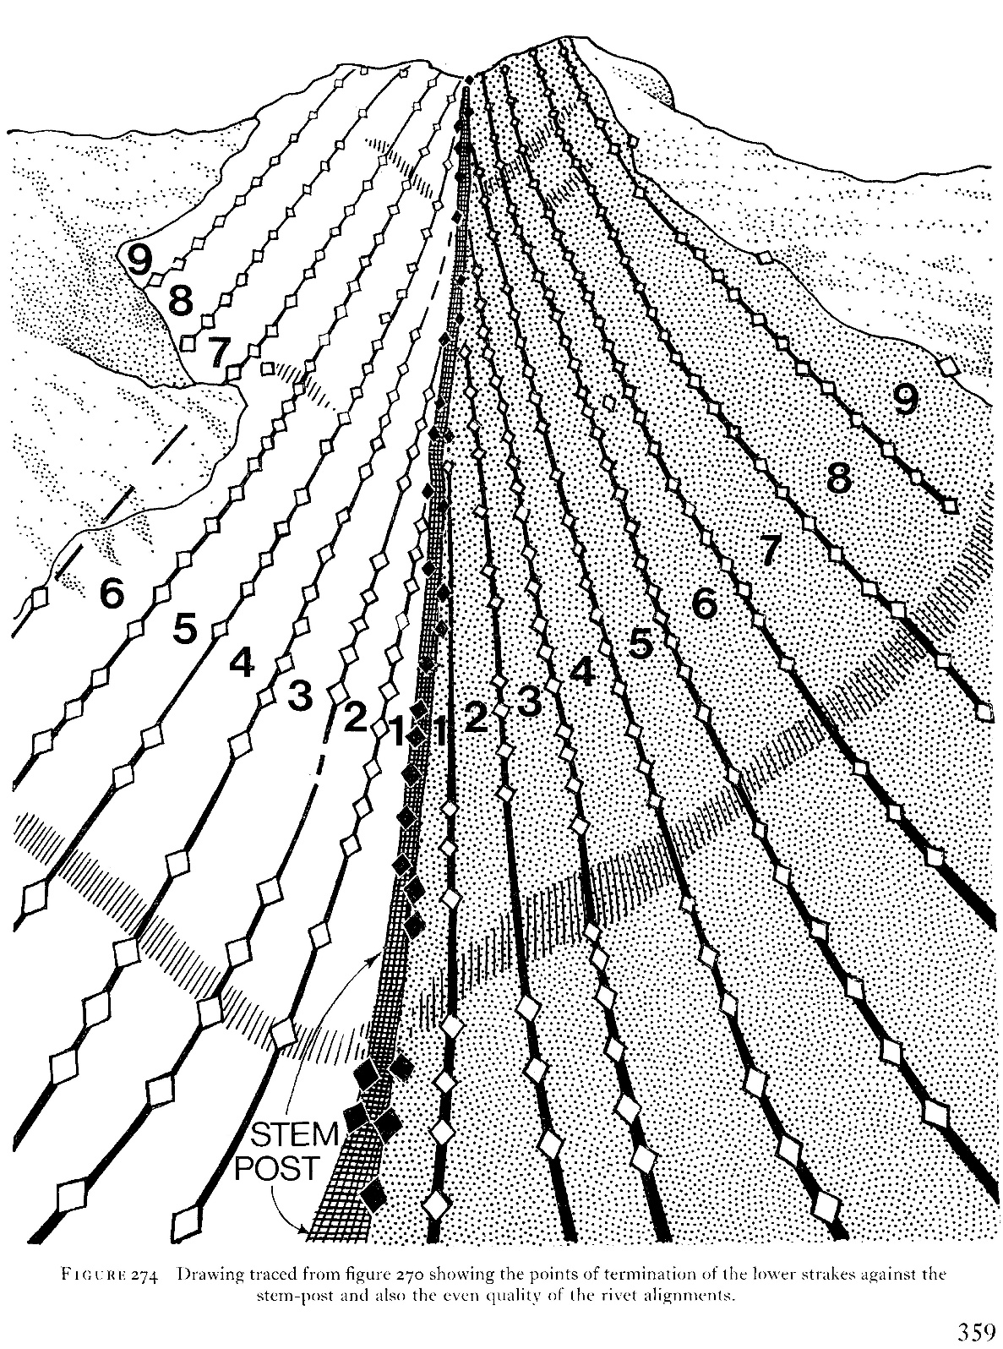
© Trustees of the British Museum
The runs of white rivets in fig. 274 that link each strake to the next are described on p. 357: ‘…the rows of rivets ran in uninterrupted sequence to the stem-post with the planks narrowing to perhaps 2½ in. (5 cm)’. This seems to indicate that the planks were run in to the hood ends evenly. The planks appear to be the same each side if the white rivet lines are taken as an indication. The number of rivets may vary slightly, but that would be determined by the nature of the planks being pulled in. Sometimes it may require a slightly closer spacing to pull in a tricky section, and so forth.
The interpretation of the rivets that fix the strakes to the stem, shown in black in fig. 274 on p. 358, is: ‘… a pattern emerges of high-sweeping narrow planks, whose junction with the stem-post (and by inference the stern-post) was probably carefully staggered in the sense that the pairs of strakes did not run into the stem- and the stern-posts immediately opposite each other.’
Evans (1975, pp. 388-390) discusses in some detail the difficulties of interpretation Charles Phillips and Lt.-Commander Hutchison had had in 1939. The work in 1966-67 had mitigated this by close examination of both the 1939 photographs and the rivets themselves. From p. 390 ‘We can now see (figs. 270 and 274) that the hood-ends ran individually and alternately into the stem post with one further rivet, other than an apex rivet, securing the oblique end of the plank to the stem-post.’
The difficulty of this whole process of fixing the hood ends was one that Scandinavian builders took very seriously and why they experimented to the extent of using ‘stealers’. By elaborating and extending the stem, the final fixing of the ends of the planks are moved much further back from the front of it. The Oseberg ship is an example of this. Evans (1975, p. 357) rejects this possibility, but recognises in footnotes that in 1939 the opinion of Phillips and Hutchison was that stealers appeared to have been used at both the stem and the stern. See Phillips (1940, p. 184), and his log for 23 Aug 1939. (N.B. the stern was not available in 1966-67, having been destroyed in World War 2.)
- Discussion, based on the practical experience of P Constantine
Fixing planks to the hood ends is one of the most difficult processes in clinker building, as the planks are no longer wide, and they are twisting. The lower edge of the plank is the hardest part to pull in. These days they are usually held with screws that can be tightened slowly, then left for some time for the timber to stretch, and then tightened again … and so on. The Anglo-Saxons did not have this luxury and could have used other clamping techniques for easing this task.
However, Constantine would not expect the final fastenings of each strake to the stem to always be precisely the same on each side, because at this particularly challenging job you have to apply the fixings where you can and in response to the particular demands of the plank that you are dealing with. Some planks go in perfectly and you get them with two fixings. Some are particularly stubborn and you may have to use more fixings if you have the space. Your great hope is that you do not split the plank and that you do not split that bit of the stem that you are trying to fix to. The pointed shape of the bow means that you cannot easily cramp onto it. You cannot access the inside to clench a rove onto the rivet. Sometimes it is possible to go right through and hold both planks, but this was not done in this case. Force has to be applied with Spanish windlasses or wedges or props etc.
The inconsistencies in rivets/fixings are for those shown in black, and these are the very ones that fix the strakes to the stem. In some places they are missing and in others they appear doubled-up. Constantine has reservations about the planks being staggered. It seems to have been an archaeologist’s suggestion, which no-one on site with practical, relevant expertise was able to challenge at the time.
  - Note on the fixing to the stem
Evans (1975, fig. 290, p. 377) shows a possible stem-post section at the level of rib 1. Rivets are shown evenly on each side. The roves are shown in the usual way, with the roves inside the ship, and possibly rather awkward to clink.
Fenwick, 2018, drew our attention to rivet 2000, shown on Card 8 from the Map Pocket of Bruce-Mitford, 1975. This shows the head on the inside of the stem-post, and the rove on the outside. The state of the ship 1966-7 makes it difficult to locate ribs 1 and 2, but projecting from ribs 3 onwards it looks as if rivet 2000 was a short distance inboard of rib 1.
- Conclusions
There is no evidence that stealers were used at the stem or at the stern. Although Evans, 1975, suggests the hood ends at the bow may have been deliberately staggered, this is felt to be dubious. The arrangement of the rivets for the hood ends is not that tidy, but could just be a result of doing the best one can at a difficult job. There is evidence from one rivet that that it may have been used ‘the wrong way round’ because the position made it difficult to clink otherwise.
- History

Status | Date | Author | Details of change
Published for Symposium | 6/10/18 | Paul Constantine  Joe Startin | Published after two drafts
Draft 0.1 for review | 22/2/19 | Joe Startin | Added History section.
Issue 1.0 | 6/3/19 | Joe Startin | Gave explanation of stealers in section 2. Removed hint in section 3 that we may have known certain techniques used by Anglo-Saxons.
Issue 1.1 | 16/4/20 | Joe Startin | Added copyright notice at beginning.

- References
BRUCE-MITFORD R., 1975. The Sutton Hoo Ship Burial, Volume I. London. British Museum

EVANS A. C., 1975. The Ship. In: BRUCE-MITFORD R. (ed.), 1975. The Sutton Hoo Ship Burial, Volume I. London. British Museum, 353-413

PHILLIPS, C. W., 1940. The Excavation of the Sutton Hoo Ship Burial, The Antiquaries Journal, XX (2), 149-202

FENWICK V., 2018. Private communication

