The Gunwales of the Sutton Hoo ship
Joe Startin
Document SHSC005, Draft 1.1
The Sutton Hoo Ship’s Company, The Longshed, Tidemill Way, Woodbridge, IP12 1FP
Email: contact@saxonship.org
Website: www.saxonship.org

Copyright © 2018-2020 The Sutton Hoo Ship’s Company. Permission granted to reproduce for personal and educational use only. Commercial copying, hiring, lending is prohibited.

Abstract: The Sutton Hoo ship had nine strakes, and the topmost strake, the gunwale, is the most important strake structurally. The evidence is that it was thicker and more substantial than the other strakes. It supported the tholes used to transmit the power from the oars to the rest of the ship, but whether the tholes ran along the gunwales amidships is controversial. The starboard gunwale in particular may have been integral to the steering arrangement. The gunwales would need to withstand potential abuse from repeated loading and unloading of the ship. It is conjectural that each gunwale was an unbroken mid-section, with joints near the ends. This paper attempts to characterise them from the information available.
Keywords: Sutton Hoo ship, gunwale, strake, thole, spike, rib bolt, scarf.

Introduction
The Sutton Hoo ship had nine strakes, and the topmost strake, generally referred to as the gunwale, can be expected to be tougher than the others. Common sense suggests it was the most important strake structurally. It also needed to support the tholes used to transmit the power from the oars to the rest of the ship. The starboard gunwale in particular may have been integral to the steering arrangements (Startin, 2019a). The gunwales would need to withstand potential abuse from repeated loading and unloading of the ship.
The evidence is that it was thicker and more substantial than the other strakes. This paper attempts to characterise it from the information available.
Evans, 1975, gives a suggested cross-section of the gunwale in fig. 290 on p. 377. It is reproduced here, out of chronology, as it does help orientate the reader. She shows it as just over 3 in. thick at the top and about one inch thick at the bottom:

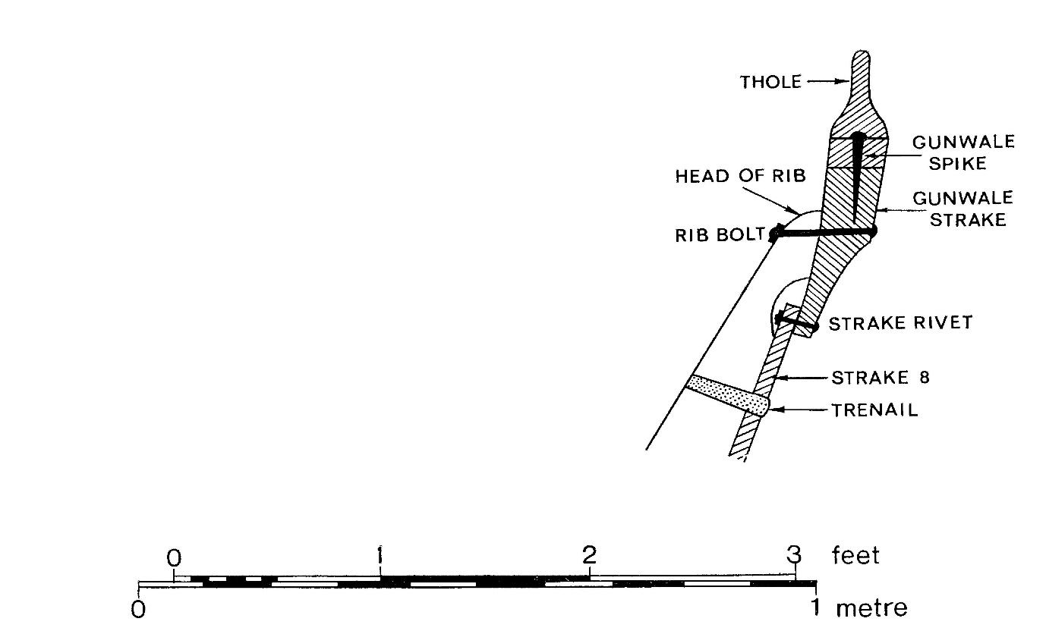
© Trustees of the British Museum

Evidence from 1939
Phillips (1940a, p. 187) says ‘The gunwales contained four pieces of wood only and must have been very heavy, for the tholes were secured to them by pairs of iron spikes, 6 in. long, driven in vertically, each pair being spaced not more than 3½ in. apart, while in some places three spikes occurred.’
This could imply that what was left of the gunwales on each side had a single joint. This would be significant, but it is not mentioned later, or in Phillips, 1940b. It is certainly not supported by Evans, 1975.
Fig. 12 on p. 186 shows the suggested arrangement for the upper strakes, tholes and ribs, including a scale.

‘Re-entrant curves’?
Phillips (1940a, p. 190) says ‘The gunwale lines of the ship, which in plan show graceful re-entrant curves fore and aft…a small rounded stern.’ This is discussed in Startin, 2019a. Also there is no information about how the gunwales continued towards the stem and the stern, or how the ends were fixed at the stem- and stern-posts (Startin 2019b). Anderson, 1942, takes Philips to task on this, and argues that the apparent re-entrant curves arose from plank-spreading. He makes a persuasive case for how to adjust the lines of the gunwales to give ‘normal pointed ends’ to the ship

Thickness of the gunwale
Phillips (1940a, p. 187) says ‘It has already been said that the gunwales must have been heavy pieces of timber. Fig. 5 shows a cross-section of gunwale remains, amidships, where they had been distorted by the pressure of the burial-chamber roof. The presence of much leached sand suggests the decay of thick wood, but the exact details must remain unknown.’ Fig. 5 is a sketch of a section made between ribs 12 and 13 on the starboard side, showing the relation between the gunwale and the roof of the burial chamber – it is reproduced in Bruce-Mitford (1975, fig. 113).
However, Phillips (1940a, p. 189) also implies a gunwale not much thicker than a normal plank. He says that ‘The ribs were secured to the skin of the ship at each end through the gunwales by a clench nail 4⅛ in. long (fig. 14). At the other points between the ends the method of attachment to the skin of the ship left no trace.’ (Fig. 14 is a scale drawing of the nail.) How much of this 4⅛ in. is accounted for by the head of the rib? Phillips (1940b, p. 349) says that the ribs ‘… had a rectangular cross-section and varied in width from 3 to 5½ in. and some 3 in. in depth. There were no signs of how they were fixed to the insides of the strakes, but at each end they were secured to the gunwale by an iron nail 4¼ in. long riveted over a rove in the same way as the other nails.’ Consequently the rib bolts imply a gunwale thickness of as little as 1¼ in., increasing if you allow for the ribs being a bit less deep near their top ends.
Science Museum, 1939, shows drawings of two ‘rib bolts’, and they are of the same 4¼ in. length. Unusually they are not letter-coded to show from which part of the ship they came, so their provenance is not known.
This rib bolt information presents quite a difficulty. However, there is a hint that a systematic error has been made. Crosley (1942, p. 110) says ‘The gunwale strake may have been nailed to the top of each rib, (single rib nails 6 in. long were found in this position); …’ 6 in. rib bolts would imply a gunwale up to 3 in. thick. Crosley, 1942, does not say anything else about the size of the gunwales. The discrepancy with Phillips is intriguing, as Crosley was a member of the 1939 team of surveyors from the Science Museum, and was responsible for the drawing. Bruce-Mitford, 1975, came to favour the Crosley view, see below.

Possibility of composite gunwale
Phillips (1940b, p. 351) raises the possibility of the gunwale being composite. ‘It was sometimes possible to see the imprint of the grain of the planking against the sand against which it had rested, and in the case of the gunwale it appeared in at least one stretch along the port side aft to have been made of three comparatively narrow pieces of wood placed directly one above the other. If the gunwale was thus composite it must have been held together by treenails or lashed, for there was no iron present.’ Phillips, 1940b, says little else of note about the gunwales, and there is no mention of a possible composite gunwale in Phillips, 1940a. [Such a possibility is denied in Evans (1975, p. 400) – see below.]

The distraction of ‘Plank G’
Phillips (1940a, p. 184) says that ‘An exception to the general disappearance of the wood of the hull was found on the bottom of the north-west part of the burial chamber, where a piece of strake 9 on the port side was found preserved in a recognizable condition to a length of 15½ ft. …’ Strake 9 would be the gunwale, so this attracts attention. But other context implies Philips really meant the garboard. The wood concerned is referred to as Plank G in Science Museum, 1939, and Crosley (1942, p. 111, fig.9). Startin, 2019c, describes how Bruce-Mitford convincingly attributes it to the floor of the burial chamber. So for present purposes, this is a distraction.

Evidence from 1966-67
This comes from Bruce-Mitford, 1975 and Evans, 1975.
Page 178 gives a reinterpretation of the section taken of the gunwale and burial chamber roof, described in Phillips (1940a, p. 187). It suggests convincingly that the leached sand Phillips was looking at extended too far out to be from the gunwale. This was really represented by another part of the sketch, showing some darker sand. Phillips’s sketch is compared to a 1939 photograph, fig. 108. Conclusions about the thickness of the gunwale cannot be made from it. What is illustrated, however, is the way the gunwale was crushed by the roof, transmitting the weight of the mound above it.
Evans (1975, pp. 398-406) is from Chapter V. As ‘Section 6: The gunwale and tholes’, it represents the key source.
The possibility of a composite gunwale, as raised by Phillips, is discounted. Page 400 says ‘…we are dealing with a strictly functional gunwale which is not of composite structure, as for example the Gokstad gunwale (fig. 307).’
Section 6 says the team analysed the 1939 photos, which showed that the only parts of the gunwale left were between ribs 4 and 23. The higher portions leading to the stem and the stern, where it must taper to make important joins, were areas of conjecture.
The gunwale must have been substantial:
- It was regularly pierced by heavy vertical iron spikes, up to seven inches long and about one inch thick.
- It supported a row of tholes, with their long bases.
- On page 400, five surviving rib bolts, two from port and three from starboard, are detailed, and they imply the gunwale is 3½ to 4 in. thick amidships, and around 3 in. thick at ribs 3 and 23
The rib bolts are obviously crucial evidence, and resolve questions from the 1939 story. The length of the part of the bolt which shows horizontal wood grain is assumed to have passed through the gunwale. Vertical wood grain arises from the thickness of the head of the rib, and the length of this apparently showed a marginal variation along the ship.
The join to strake 8 below is described as difficult because none of the rivets found were unbroken. Page 402 says ‘…it seems from the surviving indications of the wood grain that they are of standard shank length, i.e. 2 ± ¼ in. This would imply that the gunwale strake had narrowed to normal strake thickness of approximately one inch on the strake overlap, but how far it extended behind strake 8 is conjectural.’
Figure 290 on p. 377, reproduced in the Introduction, shows a suggested cross-section of the gunwale, taking all this into account. (To accommodate the 1939 view that at least in some places the thickness of the gunwale where the rib bolt comes through was just over an inch, such bolts would have to go through nearer the bottom of the gunwale.)
How the gunwale was jointed is also a difficult area. No evidence of vertical scarf joints, using iron bolts, similar to those used for the planks, was found (p. 402). There were clusters of vertical iron gunwale spikes around ribs 4 and 22 port, and it is possible that horizontal scarfs were used there.
There is a footnote on p.402, quoting Ole Crumlin-Pedersen: ‘One would expect to find no joints amidships, but one long central plank joined to curved end pieces at about frames 5-8 and 18-21. On the photographs of the port side may be seen many extra gunwale spikes at frames 4 and 22. The distance along the planking between these points is approximately 54 ft. The central length of the gunwale may be as long as that.’

Relation to the tholes and the burial chamber
The tholes are discussed in more detail elsewhere (Startin, 2019d), but obviously there is an intimate connection with the gunwales.
- The long vertical spikes used to attach the tholes, up to seven inches long and about one inch thick, would require gunwales of some substance.
- It is not clear whether the tholes continued along the gunwales amidships, in the area of the burial chamber. Evans (1975, p.405), Bruce-Mitford (1975, p. 419)
- From evidence on the port side it is possible that certain thole spikes served as fastenings for horizontal scarfs in the gunwales around ribs 4 and 22.
The burial chamber roof would have rested on the gunwales, and over time would have squashed it. It is not surprising that there were no tholes found in that area, but there was no trace of vertical thole spikes either. If tholes had been removed for reuse, or to allow for the construction of the roof, removing the spikes completely would have been very difficult. Horizontal iron nails were found, but these could well have been for securing the roof. See Evans (1975, p.405), Bruce-Mitford (1975, p. 419).

Conclusions
The evidence suggests the gunwales were similar in width to the other strakes. Except where they overlapped with strake 8 they were much thicker, about 3 inches. They ran continuously along each side for at least as far as ribs 4 and 22. It is possible they were jointed there, using horizontal scarfs and vertical thole spikes. There is no information about how they continued towards the stem and the stern, or how the ends were fixed at the stem- and stern-posts.

History
Status | Date | Author | Details of change
Published for Symposium. | 6/10/18 | Joe Startin | Published after two drafts
Draft 0.1 | 16/1/19 | Joe Startin | Discussion of plank G at end of Section 2 amended. History section added.
Issue 1.0 | 26/3/19 | Joe Startin | Abstract modified. Added references to four SHSC documents. Shifted 1975 drawing of suggested cross-section to the Introduction. Added a subsection 2.1 concerning ‘re-entrant curves’, and R C Andersons’ rejoinder. Clarified the nature and provenance of rib bolt evidence for gunwale thickness taken from 1939 sources. Cross-referenced this with 1975 view. Some material in Sections 2 and 3 put into subsections. 1939 mention of possibility of composite gunwale cross–referenced to the 1975 view.
Draft 1.1 | 16/4/20 | Joe Startin | Added copyright notice at beginning.

References
ANDERSON, R. C., 1942. The Sutton Hoo ship, Notes: The Mariner’s Mirror, 28 (1), 83-5
BRUCE-MITFORD, R., 1975. The Sutton Hoo Ship Burial, Volume I. London. British Museum.
CROSLEY, A.S., 1942. Survey of the 6th Century Saxon Burial Ship, Transactions of the Newcomen Society, 23(1), 109-116

EVANS A. C., 1975. The Ship. In: BRUCE-MITFORD R. (ed.), 1975. The Sutton Hoo Ship Burial, Volume I. London. British Museum, 353-413

HANDLEY, P., 2016. The Sutton Hoo Saxon Ship – Development and Analysis of a Computer Hull Model Prior to Full Reconstruction. In: Proceedings of Historic Ship 2016, London, December 2016. London. Royal Institution of Naval Architects
PHILLIPS, C. W., 1940a. The Excavation of the Sutton Hoo Ship Burial, The Antiquaries Journal, XX (2), 149-202

PHILLIPS, C. W., 1940b. The Excavation of the Sutton Hoo Ship Burial, The Mariner’s Mirror, 26 (4), 345-355
SCIENCE MUSEUM, 1939. Drawing No 2012/B, Provisional Drawing, 2 Sheets, Sheet 2. Colchester and Ipswich Museum

STARTIN, J., 2019a. Steering arrangements on the Sutton Hoo Ship. Document SHSC007, The Sutton Hoo Ship’s Company. <www.saxonship.org>
STARTIN, J., 2019b. The Stem and the Stern of the Sutton Hoo Ship. Document SHSC006, The Sutton Hoo Ship’s Company. <www.saxonship.org>
STARTIN, J., 2019c. Plank thicknesses used for the Sutton Hoo Ship. Document SHSC010, The Sutton Hoo Ship’s Company. <www.saxonship.org>
STARTIN, J., 2019d. The Tholes on the Sutton Hoo Ship. Document SHSC011, The Sutton Hoo Ship’s Company. <www.saxonship.org>

