The Stem and Stern of the Sutton Hoo ship
Joe Startin
Document SHSC006, Draft 1.2
The Sutton Hoo Ship’s Company, The Longshed, Tidemill Way, Woodbridge, IP12 1FP
Email: contact@saxonship.org
Website: www.saxonship.org

Copyright © 2018-2020 The Sutton Hoo Ship’s Company. Permission granted to reproduce for personal and educational use only. Commercial copying, hiring, lending is prohibited.

Abstract: The Sutton Hoo ship had a stem-post and a stern-post which together with the keel form the skeleton of the ship. The stem- and stern-posts were broadly similar to each other, and to those of the Nydam ship. There was little or no evidence of their upper sections, including the joins to the gunwales. Detailed work in 1966-7 led to a claim that the position and form of a (fairly short) scarf between the keel and the stern-post had probably, but not definitely, been identified. This claim disagrees with the 1939 view in many respects. It leads to a shorter keel which avoids substantial curves at each end. However this would demand longer, curved timbers for the stem- and stern-posts, and raise questions on how to support these during a build. The position and form of the scarfs will always be hypothetical. A reconstruction may be influenced by the timber available and what appears to be stronger and safer.
Keywords: Sutton Hoo ship, stem, stern, stem-post, stern-post, keel, strake, hull.

Introduction
The Sutton Hoo ship had a stem-post and a stern-post which were broadly similar. They were vital to the integrity of the hull. Their nature, how they were scarfed to the keel, how they were attached to the gunwales and how they accommodated the hood-ends of the planking are of great significance in any attempt at reconstruction.

The 1939 record
Phillips (1940a, p. 183) says of the ship ‘The only parts missing were the point of the bow and the end of the stern, the latter having been removed by the plough.’
Bruce-Mitford (1975, p. 158), using Basil Brown’s diary, indicates that the first rivet found in 1939 was at the bow, and at the level of the original ground surface before the mound was constructed. On p.162 Brown is quoted regarding the stern: ‘The end comes up quite near to the surface outside the mound and a furrow had been ploughed right over the end of the ship.’
Science Museum, 1939 shows that more was lost from the stern than from the bow. It also shows that the joins where stem- and the stern-posts meet the gunwales had been lost.
Phillips (1940a, p. 188) says ‘The stern post was armoured on the outer edge by an iron strip 1¼ in. wide by ⅜ in. thick. Only a few fragments of this and two of the nails by which it was secured were found, and there was nothing comparable observed on the stem post.’ Crosley (1943, p. 113) mentions ‘A piece of rusted flat iron bar about 5 in. long and 1¼ in. by ⅜ in. section was found near the bow which may have been part of a rubbing iron common to the stem and the stern posts; also near this were some pointed nails or spikes … probably used for securing the rubbing iron to stem.’ (There is obviously some confusion between bow and stern here. Crosley (1943, p. 110) mistakenly says the ship was canted to port, rather than to starboard, so one is more inclined to trust Phillips.) Bruce-Mitford (1975, p. 259) mentions the two nails ‘… which led to the view that an iron runner had been fixed to the stern-post’. He relates them to Science Museum, 1939, which shows detail H, described as a ‘keel-plate spike’, 2½ in. long, coming from between ribs 23 and 24. The 1960s re-excavation at the stern found no trace of it, or of anything similar at the bow.
Phillips (1940a, p.187) says ‘The stem and stern posts had also rotted completely …’

1939 position on the scarf joints to the keel
In 1939 Charles Phillips and Lt.-Commander Hutchison took much interest in the keel, the stem and the stern, taking several sections during their investigations. The only records of these sections are certain photographs taken at the time. In Phillips (1940b, p. 347) it says ‘The position of the two scarves joining the stem and the stern posts to the keel-plank was fully established between ribs 3 and 4 forward and ribs 23 and 24 aft, and they were found to have been secured by three large vertical iron nails apiece 6¾ in. long and riveted over roves like all other nails in the ship.’ Phillips (1940a, p. 184) is similar: ‘We are thus not yet clear about the keel, but the position of the scarves joining the stem and stern posts to it was fully established. These came between ribs 3 and 4 forward and 23 and 24 aft. Each was secured by three large vertical iron nails 6¼ in. long riveted over roves like all the other clench nails in the ship.’ [None of these nails has survived.]
Ribs 23 and 24 are quite a long way aft, and, given rib 13 is at the centre of the boat, are not symmetrical with ribs 3 and 4 near the bow. Bruce-Mitford (1975, footnote p. 260) says the ribs 23-24 position is impossible unless there was double scarfing.
Science Museum, 1939, also shows the scarf for the stem between ribs 3 and 4. However, at the stern it shows a 3 foot long scarf between ribs 22 and 23, so maybe the position claimed by Philips was an error. It gives a drawing of a ‘scarf-bolt’, detail F, which is 6¾ in. long, as per Phillips, but this is indicated as coming from midway between ribs 22 and 23. (The ‘keel-plate spike’ mentioned above may have caused confusion. This is mentioned in Bruce-Mitford (1975, p. 259) and Evans (1975, footnote 2, p. 394)).
Crosley (1943, p. 112) gives some support, but is rather vague: ‘On the stern post, and slightly to port, a further unusual spacing of nails was found, in such a position as to indicate the probable location of a scarf joint between the post and the keel at this point and as these nails were 6¾ in. long the depth of the keel was deduced from this dimension.’
Bruce-Mitford (1975, pp. 256-270, pp. 289-295) covers the sections cut in 1939 as well as the sections cut by his own team. But his considered view on the positions of the scarf joints is different.

Information from 1966-67 as interpreted by Evans, 1975 and Bruce-Mitford, 1975
The stem-post and the stern-post are of the style of the Nydam and Kvalsund 1 ships. They have a similar shape, and each is a single, sturdy piece of wood. There is no evidence of double-scarfing – ‘However, the possibility of a trenailed double scarf (cf. the Gokstad and Oseberg ships, fig.304) cannot be ruled out, and from a practical point of view this would involve the use of more realistic lengths of timber. A double-scarf, with a short, slightly curving fore-foot between the keel-plank and the stem- and stern-posts would give the ship a basically flat keel-plank and at the same time would reduce the length and curve of the two end-posts to more manageable portions.’ (p. 397).
In an important paragraph, Evans (1975, p. 390) describes how a detailed examination of the rivet positions, the wood grain on the rivet-shanks, and the angles of their roves, led their conclusions over the positions of the scarfs and ‘… an approximation of the cross-section of the stem-post (fig. 290) and by inference, of the stern-post’. The relevant part of fig. 290 is:
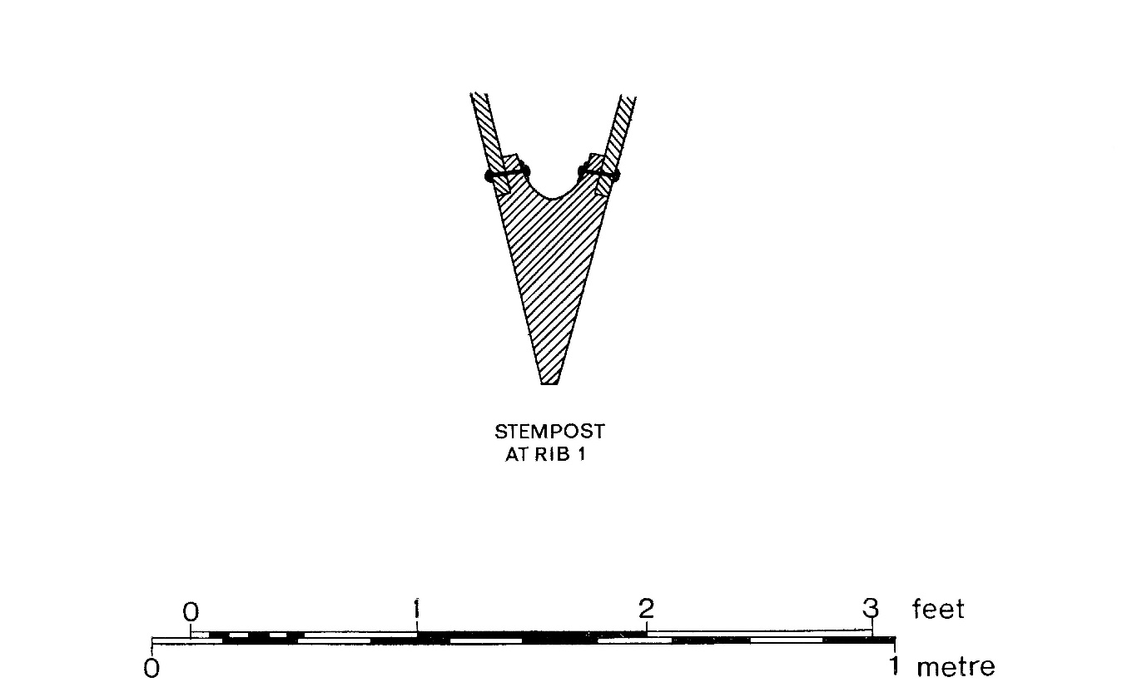© Trustees of the British Museum

How the hood-ends of the planking were attached to the stem- and the stern-posts is treated in Constantine and Startin, 2019.

Depth of stem and stern-posts
‘Depth’ here is understood to be the depth of projection below the hull, as in Table 17, p. 265. This is taken to be the vertical projection; the ‘local projection’ is term used to describe how far the wood actually sticks out from the hull, allowing for the local angle the stem or the stern makes with the horizontal.
The Science Museum, 1939, drawing shows a maximum depth of 10 in. for the stem-and stern-posts.
The ‘cut-water’ region of the bow is around ribs 3 and 4. The waterline is estimated to be at about rib 4 as an empty shell, and rib 3 when loaded to maximum.
Observations for depth of the stem-post, including information from Table 17, p. 265, about Sections J and K cut 1966-7:
- At rib 4 (photo taken 1939, fig. 295(b) on p. 385) – just under 4 in, but difficult to interpret. Local angle about 15 degrees, local projection 3.8 in.
- At rib 3 (section J, 1966-7, see drawing fig. 191 on p. 267) - 5 in. Local angle about 25 degrees, local projection 4.5 in.
- At a point 3 ft. 2 in. east of rib 3 (Section K, 1966-7, at extreme east of preserved remains, see drawing fig.193 on p. 269) - 8 in. Local angle about 35 degrees, local projection 6.6 in.
- Forward of rib 1 (photo taken 1939, fig. 297 on p. 387) - 10 in. (p. 265), or 11 in. (note under fig. 297), or ‘as much as 12 in. at its maximum’ (p. 390). Local angle about 50 degrees, local projection for the 10 in. record, about 6.4 in.

Most of the stern had been destroyed in 1942 when the site was an army training camp. Observations for depth of the stern-post, all from Table 17, p. 265. (Local angles around 25 degrees):
- At rib 23 (section E, 1966-7, 14 ft. 4 in. east of datum line) – 3.25 in.
- Between ribs 23 and 24 (section D, 1966-7, 14 ft. east of datum line) – 2 in.
- Between ribs 23 and 24 (section C, 1966-7, 14 ft. 4 in. east of datum line) – 2 in.
- Between ribs 23 and 24 (section B, 1966-7, 12 ft. east of datum line) – 4 in.
- Between ribs 23 and 24 (section A, 1966-7, 12 ft. east of datum line) – 4 in.

It will be seen that the stern measurements show wide variation over quite a small distance, and are consistently much smaller than for the stem. Cautionary words on p. 264 remind the reader how the wood of the ship sometimes shrank to the extent that it seemed disappear altogether, so all the measurements are minimum possible values. Many will doubt that the required strength at the stern is consistent with the minimum values.
The depth of the stern-post shown in the drawings Science Museum, 1939, and Bruce-Mitford (1975, fig. 325, p. 435), is all by inference from the stem-post.

Position of the scarf joints to the keel
It is evident from Section 2.1 that the story of how and where the stem and stern were scarfed to the keel is complicated and confusing. Bruce-Mitford (1975, footnote p. 260), Evans (1975, p.392, p. 394) make this clear. The interpretation of the keel has its own difficulties (Startin, 2019).
The start of Evans (1975) Section 5: The scarfs and their position (pp. 392-8), goes against Phillips’ statements given in section 2.1 above, saying ‘The placing of the two scarfs so far forward and aft at a point where the upward sweep of the stem- and stern-posts has already influenced the profile of the ship and where, as sections at the prow for example (fig. 294) show, the plank-on-edge cutwater has already developed has frequently been criticised.’
Pages 396-397 makes clear a lack of evidence. ‘Evidence for the position of the forward scarf is completely lacking. Trenails would not survive, and careful scrutiny of the photographic evidence at all stages of excavation showed that no rivets in the area of rib 3 or rib 5 could be identified as belonging to a scarf…’ ‘Unfortunately the one bolt from the after scarf that was lifted by Commander Hutchison has completely disintegrated and any reconstruction of the scarfs must be hypothetical.’
Identification of the stern scarf bolts from the 1939 photos was tricky because of the nearby repair to a garboard strake. In 1939 Hutchison cut a section between ribs 22 and 23 after photos were taken of the rib 21 area – there is speculation he was searching for a second scarf, maybe because he was distracted by the repair, or maybe by the runner mentioned in section 2 above. After much discussion (pp. 392-396), Evans favours three bolts, just forward of rib 21, as a short scarf. It is comparable to the short scarf used on the Graveney ship. It would also use scarf bolts 6¼ in. long, as described by Phillips (1940a, p.187) – such bolts would be too short for a scarf position between ribs 22 and 23.
Evans (1975, p. 398), gives the view: ‘It seems unlikely that the problem of the keel-scarfs, with the stem- and the stern-posts, can be finally resolved. Shipbuilding traditions suggest strongly that the scarfs should be moved amidships to lie between ribs 5 and 6, and ribs 20 and 21, which would give a flat keel-plank and long low-raking stem- and stern-posts.’
Even so, Evans is at pains to spell out later on p. 398 a range of possible interpretations of the evidence:
‘To summarise: the alternatives are
- A single scarf between ribs 21 and 20 and ribs 5 and 6 (giving a flat keel with a length of 46 ft. [12 m (sic)]);
- A single scarf between ribs 22 and 23 and ribs 3 and 4, giving a keel with a substantial curve at each end and a total length of 57 ft. [17.4 m];
- A double scarf with a lower join at ribs 21 and 6 and an upper join near ribs 23 and 3.’
Alternative (1) actually shows some inconsistency. 46 ft. is the distance from scarf to scarf, but this converts to just over 14 m, not 12 m. It is just possible that Evans’ 12 m is the length she estimates for the flat portion of the keel.
Alternative (1) is partly portrayed in fig. 325 on p. 435, the archaeological reconstruction of the ship based on the 1939 photographs and the information gained in 1966-7. It gives the position of the three rivets used for a foot-long scarf where the stern post was attached, just forward of rib 21. It also shows where a similar scarf joint to the stem was located, using three hypothetical treenails just aft of rib 5. However, fig. 325 does not show a keel plank that is flat for 46ft. [14 m]. The rocker shown is at least 6in. (15 cm) at each scarf, and 3 in. (7.5 cm) over the central 39 ft. [12 m] part of the keel, even though it avoids the substantial curves at each end required of alternative (2).
The scarf for the stem is entirely hypothetical. No traces were found in 1939 or 1966-7. This negative evidence suggests the use of trenails. All claims are by inference from the stern.

Discussion
The short scarfs proposed by Evans and Bruce-Mitford are controversial when it comes to a reconstruction. The keel is shorter, but the stem and stern posts will be longer, and as curved pieces of wood could turn out to be very difficult to source.
Also, the smallness of the joints suggests to current experts that the stem and stern would need independent support while the hull planking was in progress. Maybe the joints would be adequate once the planking had been completed. This could be a feature that Anglo-Saxon shipbuilders had learned over centuries of experience. But a credibility issue could remain, and this would cause trouble when considering the safety of a crew in a rough sea.
It may turn out that this part of any reconstruction has to be guided more by the availability of suitable timber and by what appears to be convincingly safe.

Conclusions
The parts of the stem and the stern around and above the gunwales were never found. Sections 3.1 and 3.2 above summarise the evidence concerning the shape of the parts which remained. Detailed work in 1966-7 led to a claim that the position of a (fairly short) scarf between the keel and the stern-post had probably, but not definitely, been identified. This claim disagrees with the 1939 view in many respects. It leads to a shorter keel of simpler shape, which may be easier to source – but also to longer stem and stern-posts. The short, small scarfs proposed may be too bold a step when it comes to a reconstruction which can be safely tested.

History

Status | Date | Author | Details of change
Published for Symposium. | 6/10/18 | Joe Startin | Published after two drafts
Draft 0.1 | 25/11/18 | Joe Startin | More detail on position of the scarfs. Added discussion on practicalities of accurate reconstruction. Added History section
Issue 1.0 | 4/4/19 | Joe Startin | Abstract modified. In section 2.1, clarified lack of end-to-end symmetry in Phillips’ description of scarf positions. In section 3, added a reference, and extended the quote concerning a possible double-scarf. In section 3.1, more detail on measurements of stem, amplified comments on depth of stern-post. In section 3.2, mentioned the 6¼ in. long scarf bolt evidence from Phillips. Also quoted all three alternatives offered by Evans and Bruce-Mitford, and drew attention to the rocker actually shown in fig. 325 (which is otherwise his alternative (1))
Issue 1.1 | 1/4/20 | Joe Startin | Elaborated Section 3.1, introducing notion of ‘local projection’.
Draft 1.2 | 16/4/20 | Joe Startin | Added copyright notice at beginning.

References
BRUCE-MITFORD, R., 1975. The Sutton Hoo Ship Burial, Volume I. London. British Museum
CONSTANTINE, P., and STARTIN, J., 2019. Hood Ends on the Sutton Hoo Ship. Document SHSC001, The Sutton Hoo Ship’s Company, Woodbridge. <www.saxonship.org>
CROSLEY, A.S., 1942. Survey of the 6th Century Saxon Burial Ship, Transactions of the Newcomen Society, 23(1), 109-116

EVANS A. C., 1975. The Ship. In: BRUCE-MITFORD R. (ed.), 1975. The Sutton Hoo Ship Burial, Volume I. London. British Museum, 353-413

PHILLIPS, C. W., 1940a. The Excavation of the Sutton Hoo Ship Burial, The Antiquaries Journal, XX (2), 149-202

PHILLIPS, C. W., 1940b. The Excavation of the Sutton Hoo Ship Burial, The Mariner’s Mirror, 26 (4), 345-355
SCIENCE MUSEUM, 1939. Drawing No 2012/B, Provisional Drawing, 2 Sheets, Sheet 2. Colchester and Ipswich Museum.

STARTIN, J., 2019. Size and Shape of the Keel of the Sutton Hoo Ship. Document SHSC003, The Sutton Hoo Ship’s Company, Woodbridge. <www.saxonship.org>

