Steering arrangements on the Sutton Hoo ship

Paul Constantine, Joe Startin

Document SHSC007, Draft 1.1

The Sutton Ship’s Company, The Longshed, Tidemill Way, Woodbridge, IP12 1FP
Email: contact@saxonship.org
Website: www.saxonship.org

Copyright © 2018-2020 The Sutton Hoo Ship’s Company. Permission granted to reproduce for personal and educational use only. Commercial copying, hiring, lending is prohibited.

Abstract: Very limited evidence remains regarding the steering arrangements which were used for the Sutton Hoo ship. This paper identifies what that evidence is. It does seem to imply that the boat was steered using a single oar or rudder on the right-hand side. This leaves enormous scope for speculation.

Keywords: Sutton Hoo ship, steering, rib, quincunx, stern, rudder.

Introduction
Very limited evidence remains regarding the steering arrangements which were used for the Sutton Hoo ship. This paper focuses on what that evidence actually is.

The 1939 story
Phillips (1940a, p. 189) says, ‘The stern contained some interesting special developments connected with the steering. Ribs 24 and 25 were only 18 in. apart and were clubbed at the starboard side and secured to the skin of the ship by a quincunx arrangement of clench nails 5 in. long.’ (By ‘quincunx arrangement’ Phillips means similar to the spots on the side of a die showing a five.)

The figure below is part of Bruce-Mitford (1975, fig. 325, p. 435), and is here to illustrate the key features. Imagine a vertical, longitudinal section through the centre line of the keel, and looking at the interior of the boat.

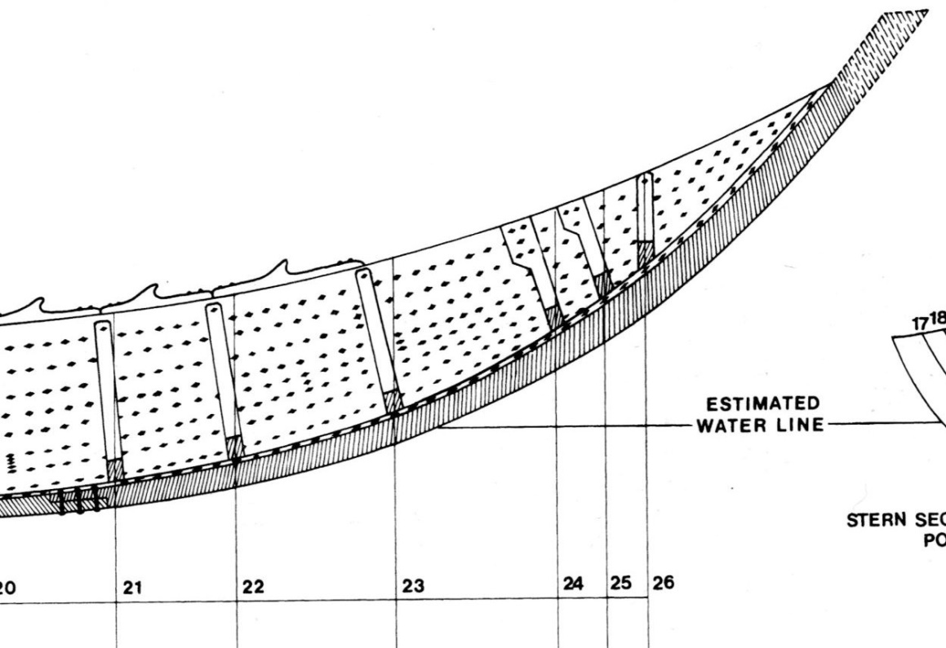
© Trustees of the British Museum

Phillips 1940a and 1940b give similar descriptions. They all say that both rib 24 and 25 had the distinctive quincunx of rivets. The diagram above shows only 24 with the quincunx, because this was disputed in 1966-7.
Phillips’ diary for Wednesday 16 August, as recorded in Bruce-Mitford (1975, p. 745), says, ‘It was found that not only the most forward of the three ribs high in the stern had been strengthened on the starboard side in connection with the oars but that the middle one of the three [rib 25] had a similar if slighter arrangement.’
Phillips’ entry for Wednesday 23 August says, ‘It was also found that no more remains recognisable on the outside of the boat on the starboard side of the stern where there was extra strengthening ribs for the attachment of the steering oar. There was no wooden button …’
Phillips 1940a, 1940b and 1940c all say that no trace of a steering oar or rudder was found, nor any trace of what might have fastened such an item.
Crosley, 1943, has two drawings, which are identical to those produced for detail J in Science Museum, 1939:
- Fig. 13 shows a ‘steerage frame bolt’ with a 5 in. long shank of ½ in. diameter, with a ⅜ in. deep head and a slightly angled rove. The main view seems to indicate that such a bolt came from the top two of either rib 24 or rib 25.
- Fig.14 shows the starboard head of rib 24 with its quincunx of rivets, the upper two rivets passing through the gunwale, and the lower three through strake 8. Measurements are given to the nearest sixteenth of an inch.
On p. 114 Crosley says, ‘It will be noticed that the last rib at the ship’s stern is vertical whilst all the other ribs are mostly at right angles to the keel line at their respective positions. This vertical rib may be thus placed to serve the additional purpose of the framing of a seat for the steersman of the ship.’ This could be taken as an obvious remark, but we have not seen it elsewhere in the record.
Philips (1940a, p. 190) says, ‘The gunwale lines of the ship, which in plan show graceful re-entrant curves fore and aft, run almost parallel as they approach the stern, and it is difficult to believe that this feature ended in a sharp point as in the Nydam boat. It may be suggested that it had a small rounded stern.’ [Phillips probably means the Nydam oak ship, of circa AD 320, described in Bruce-Mitford, 1975, and widely covered in the literature. ‘Nydam boat’ usually means the smaller companion found with it, made from fir.] Philips (1940b, p. 351) and (1940c, p. 26) and run a similar theme. Anderson, 1942, talks of plank-spreading and argues against this.

The 1966-7 investigation
Evans (1975, p. 406-410) is ‘Section 7: The steering system’. She starts by saying that there is not much to add to Philips’ account, and makes it clear that the system had been destroyed during World War II. They were dependent on the photographic record from 1939 and a single surviving rivet from the rib 24 quincunx.
The 1939 photo, fig. 311, p. 406, is a good general view, with a tracing opposite, fig, 312, p. 407. Figures 313 and 314 on the following pages are photos which show more detail of the ‘steering complex’, the heads of ribs 24 and 25.
Evans claims, pace Phillips, that rib 25 did not have a quincunx of rivets – ‘Its club head was secured to the gunwale by certainly two, but no more than three, rivets (fig. 313), arranged in an inverted triangle.’ The photos look quite convincing. Also rib 25 does look less substantial than rib 24.
The pattern of the quincunx in the tracing shows the central rivet misleadingly high when compared with fig. 314, or detail J of Science Museum, 1939. This is probably because the tracing is not rendering the concavity of the head of rib 24 adequately.
The single surviving rivet came from lower aft of the quincunx, and was 4.4 in. between head and rove (p. 408). It was slightly curved, ‘almost certainly due to pressure.’ The vertical wood grain, characteristic of the rib, showed for 3.1 in.
This leaves 1.3 in. for the strake. The angle of the rove is vertical, which may suggest that the thickness of the head of the rib remains the same higher up. Evans implies that this rivet went through the gunwale strake, but all the pictures show that the lower three rivets passed through strake 8.
Fig. 312, the tracing, makes it very clear that there was a gunwale spike on the starboard side, just forward of rib 24. Bruce-Mitford (1975, p. 417) says that this fits in awkwardly with theories about tholes, adding, ‘This may be some local arrangement to do with the steering mechanism.’
When discussing the problem of understanding the hood-ends in the bow, Evans (1975, p. 388) says, ‘The situation is a little different in the stern where the planking has sprung away from the stern-post and creates an illusion of a small semi-circular stern.’ Her interpretation of the 1939 photos therefore implies that Philips’ (and maybe Crosley’s) first-hand impressions should be treated cautiously.

Limited interpretation
There is not much in the way of hard evidence concerning the steering arrangements. However, the ribs do appear to be asymmetrical. A plausible explanation for this is that the boat was steered, in some manner or other, using a single oar or rudder on the right-hand side.
Evans (1975, p. 373), discussing the way ribs were attached for the Graveney and Grestedbro boats, and for the Tudor clinker-built Blackfriars III wreck, says, ‘It is perhaps possible to imagine that these boats represent a conservative, but continuous, boat-building tradition outside the Viking sphere of influence.’ Also, the rectangular section of the ribs could suggest that there was a legacy from a Roman shipbuilding tradition. The Roman Mainz ships, which may have had a similar function to the Sutton Hoo ship, used distinctive double rudders. That seems to be ruled out, and something closer to that seen for the Nydam Ship, or other reconstructions in the Scandinavian tradition, seem to fit more comfortably.
If this is accepted, there remains scope for all manner of speculation. None of the sources quoted, for example, are able to resist this temptation. The scope for speculation could possibly be limited after extensive trials of a number of potential steering arrangements on a reconstruction.

Conclusions
Very limited evidence remains regarding the steering arrangements which were used for the Sutton Hoo ship. This paper identifies what that evidence is. It does seem to imply that the boat was steered using a single oar or rudder on the right-hand side. This leaves enormous scope for speculation, which it may be possible to limits after trials on a reconstruction.

History

Status | Date | Author | Details of change
Published for Symposium. | 6/10/18 | Paul Constantine  Joe Startin | Published after two drafts
Draft 0.1 | 23/2/19 | Joe Startin | Added a History section
Issue 1.0 | 6/3/19 | Joe Startin | Explained ‘quincunx’. Clarifications around Nydam ship/boat. Section 4, eased the inference from asymmetrical ribs, and mentioned how trials might put some limits on speculation.
Draft 1.1 | 16/4/20 | Joe Startin | Added copyright notice at beginning.

References
ANDERSON, R. C., 1942. The Sutton Hoo ship, Notes: The Mariner’s Mirror, 28 (1), 83-5
BRUCE-MITFORD, R., 1975. The Sutton Hoo Ship Burial, Volume I. London. British Museum
CROSLEY, A.S., 1942. Survey of the 6th Century Saxon Burial Ship, Transactions of the Newcomen Society, 23(1), 109-116
EVANS A. C., 1975. The Ship. In: BRUCE-MITFORD R. (ed.), 1975. The Sutton Hoo Ship Burial, Volume I. London. British Museum, 353-413

PHILLIPS, C. W., 1940a. The Excavation of the Sutton Hoo Ship-burial, The Antiquaries Journal, XX (2), 149-202
PHILLIPS, C. W., 1940b. The Sutton Hoo Burial Ship, The Mariner’s Mirror, 26 (4), 345-355
PHILLIPS, C. W., 1940c. The Excavation of the Sutton Hoo Ship-burial, Antiquity, XIV, 6-27
SCIENCE MUSEUM, 1939. Drawing No 2012/B, Provisional Drawing, 2 Sheets, Sheet 2. Colchester and Ipswich Museum

