The Ribs of the Sutton Hoo ship
Paul Constantine, Joe Startin
Document SHSC009, Draft 1.1
The Sutton Hoo Ship’s Company, The Longshed, Tidemill Way, Woodbridge, IP12 1FP
Email: contact@saxonship.org
Website: www.saxonship.org

Copyright © 2018-2020 The Sutton Hoo Ship’s Company. Permission granted to reproduce for personal and educational use only. Commercial copying, hiring, lending is prohibited.

Abstract: The Sutton Hoo ship had 26 ribs, spaced approximately 3 ft apart, with indications of a flat top surface, width around 3” to 5” and depth around 3”. The top ends were secured to the gunwales with an iron bolt. There is some positive evidence that trenails were used to attach the ribs to other strakes, and that the underside of the ribs was shaped to the planking. Given that, the likelihood of securing ribs to planks by cleats and lashings is less likely.
There is no evidence, one way or another, of the method of construction of the ribs: one piece grown, two piece or three. They were not always absolutely straight when going across the ship.
Keywords: Sutton Hoo ship, rib, strake, gunwale, stem, stern, keel, strake, rivet, trenail, hull.

Introduction
The Sutton Hoo ship had 26 ribs, and how they were made and how they were fixed to the hull is obviously of great interest. Some features of the ribs are clear, but many are not. This paper tries to summarise the evidence from the record, to help the reader judge for his or her self what is definite, what is plausible, what is entirely a matter for speculation.

The 1939 record
Phillips (1940b, p. 349) says of the internal framework of the Sutton Hoo ship: ‘As far as this survived it consisted of 26 ribs set at a more or less constant distance of 3 ft. apart and running from gunwale to gunwale round the inner form of the hull. They survived in the form of nothing better than black dust, but with care it was possible to see that they had had a rectangular cross-section and varied from 3 to 5½ in. in width and some 3 in. in depth. There were no signs of how they were fixed to insides of the strakes, but at each end they were secured to the gunwale by a nail 4¼ in. long riveted over a rove in the same way as the other nails.’
Here ‘width’ means the thickness of the rib across the upper surface. The term ‘depth’ is probably intended as the distance from the upper surface to the planking.. If it was taken as the vertical distance from the upper surface to the planking, the ‘depth’ of an otherwise uniform rib will vary considerably across the breadth of the ship.
Science Museum, 1939, echoes this in a note on the drawing – ‘The ribs of the ship were outlined in sand as a grey black powder & varied in width between 3 to 5½ in. but are shown one width on this drawing.’ (That width is around 4 in.). There is also a note on the vertical section by the base of Rib 10, saying ‘Found to be 5” deep at this Rib’. Concerning the drawing, Bruce-Mitford (1975, p. 235) makes an interesting comment: ‘The ribs appear of square section on the drawing, as if cut in a sawmill; they might be expected to be rounded, as in the case of the Nydam ship, to avoid the wearing and cutting of the lashings which fastened the planks, vis cleats cut in the solid on the insides of the planks, if this was the method used. True sharpness of cross-section might imply the use of trenails, not lashings.’
Science Museum, 1939, shows a drawing of a rib-bolt, but does not say which rib it came from. Its overall length is 4½ in., similar to Phillips above, and it has a slightly angled rove.
Phillips (1940a, p.189) is consistent, with a slight variation on the description ‘… and frequently still retaining a marked rectangular cross-section. In some cases the sand had formed a rough cast of the decayed wood so that if this was breached, discoloured sand tended to pour out of the hole leaving a rectangular-sectioned cavity.’
Crosley, 1942, has little to say.
Phillips (1940a, fig. 12, p.186) is a drawing of the way he thinks the upper strakes, together with the ends of ribs 19 and 20, may have appeared from the inside. The ribs are shown slightly waisted where they cross strake 8.
There are many photographs from 1939. Good examples reproduced in Bruce-Mitford, 1975 are:
- General views. Fig. 92, p. 138; Fig. 266, p. 345; Colour Plate J, p. 425.
- Stern. Fig. 300, p. 393; Fig. 275, p. 360; Fig. 281, p. 366.
- Bow. Fig. 282, p. 367, Fig. 266, p. 345 again
- Ribs 17 – 20. Fig. 283, p. 368
- Ribs 24 – 26. Fig. 311, p. 406 (with tracing on p. 407)

Information from 1966-67 as interpreted by Bruce-Mitford, 1975 and Evans, 1975
Pages 250-251 describes how ribs 24 – 26 were lost during World War II, and p.284 describes how the ribs were handled when taking the plaster cast of the hull.
From fig. 190, p. 245, all the sections cut across the ship in 1966-7 avoided the ribs, apart from J, which went through the remains of rib 25. (The sections themselves are described on p. 293)
Page 346 says the rib-spacing was checked as far as possible to see if the varying values along the ship which are evident from Science Museum, 1939, were correct. No more information is given, and the values are reproduced in the archaeological reconstruction fig. 325, p. 435, so by implication, they were correct.

Suggested arrangement at head of a rib
Evans (1975, fig. 290, p. 377) shows a suggested cross-section of the gunwale, and includes the possible arrangement at the head of a rib:
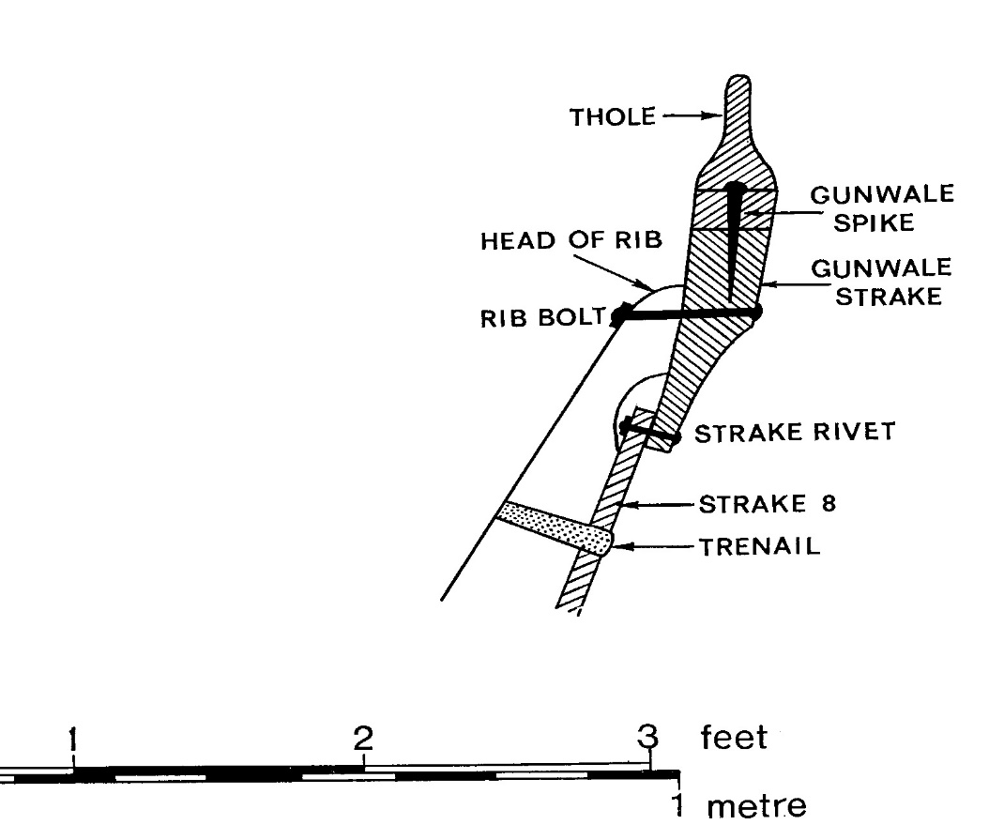© Trustees of the British Museum

Summary of main points on ribs
Evans (1975, pp. 365-373) is a section on the ribs, and is the principal source of information. The main points are:
- Many attempts to section across the ribs were inconclusive (p. 366). They were unable to show whether ‘… the ribs had been shaped to a rectangular cross-section, or whether they were naturally-grown timbers adapted to the shape of the ship.’
- Page 367. ‘Evidence from the few surviving rib-bolts suggests that the head of each rib was planed off and the approximate angle can be deduced from rib-bolts which had heavily angled roves (fig. 278 and 279).’ It has to be said that this angling of the rove is absent in the drawing fig. 279 (B). It is present in fig. 278 (C), where the rove is tilted away from (or towards) the camera. In both cases, the shank length is 6½ in. Fig. 278 (D) shows a shank length of just under 6 in., with no apparent angling.
- Page 367. ‘High in the stern, for example (fig. 275), ribs 24, 25, 26 were perhaps more than a foot deep, and the same would have been true of the ribs in the prow.’ This seems an exaggeration, unless thinking of the vertical depth, nearer the sides of the ship. Fig. 311, p. 406 (with tracing on p. 407) includes a scale in the photo which can be used to judge this, provided one takes care to compensate for the projective distortion arising from the various angles of viewpoint.
- Page 367. By 1965 no ribs had survived high enough to take a view on the waisting at strake 8, as drawn by Phillips. Fig. 287, p.372, the 1939 photo of rib 17, may hint at this, but photos of other ribs are inconclusive.
- Page 369. ‘The photographic evidence from 1939 and the 1965-7 plans [see the cards in the back pocket of Volume I] show that the line of the ribs did not necessarily run straight across the ship, but tended to be slightly sinuous.’ This is similar to the Graveney boat.
- Page 369. ‘One detail that remains totally unknown is whether the ribs were made from a single piece of timber, as was the case with the Nydam boat, or whether, as in the Graveney boat (fig. 285) the cross-timbering was composite with floor timbers which were rabbeted for side-frames.’
- Pages 368-371. After comparison with other boats, and some speculation, the attachment of the rest of the ribs to the hull was felt be ‘… shaped over the strake lands and trenailed through the hull.’ Lashings, cleats or chocks were not involved.
- Page 371. Expanding on the point above: ‘… it would imply that the underside of the ribs was shaped to fit over the ridges made by the overlapping ridged of the planking…This is a technique that pre-supposes the use of trenails. Despite intensive searching through contemporary photographs, only in three instances could faint traces in the sand of the ribs be convincingly interpreted as evidence for the former existence of the use of trenails.’ Fig 287 on p. 372 is a 1939 photo of detail on rib 17, with an arrow showing a ‘trenail ghost’.
- Page 371. And further: ‘…certain…strake rivets that lay underneath some of the ribs had traces of wood grain running across the rove, and this would suggest that the ribs fitted closely across the hull. If they had stood away from the hull on cleats, sand would have quickly filled the spaces between so that the wood grain would not have formed.’
- Page 371. Rib-bolts evidence was only available from a few that survived from 1939, none were found in situ. They ‘…suggest that the thickness of the head of the rib was not constant but varied over a couple of inches.’
- Page 400. Evans mentions rib-bolts again when she is discussing the thickness of gunwale. She says, ‘…the essential measurement [regarding the gunwale] is the horizontal wood grain which runs across the head, as opposed to the vertical wood of the rib. The total length of the rib-bolt is not especially meaningful as far as the gunwale strake is concerned as this reflects the thickness of the rib head, which varies marginally throughout the length of the ship.’ She then duly gives only the length of horizontal grain measurement for the five surviving rib-bolts, which is unfortunate. Two of these rib-bolts are shown as radiographs (C) and (D) in fig. 278 (p. 363), where the total lengths of the shanks are 6½ in., and just under 6 in. But there is no link to identify these rivets against the list of the five gunwale-thickness measurements, which vary from 2.7 in. to 4.0 in. The place where the wood grain changes is not obvious from the radiographs, but I can see a possible transition for fig. 278 (C). All we can say from fig. 278 (C) is that the rib head there was 2.5 to 3.8 in. thick (with a possibility of 3.1 in. if I identified a transition correctly.) Fig.278 (D) implies the rib head there was 2.0 to 3.3 in. thick.
- Page 373. ‘In the face of largely negative evidence it seems most probable that a technique similar to the one used by the builders of the Grestedbro [SW Jutland, AD 600-650?] and Graveney [AD 870] boats was used in the Sutton Hoo ship. The ribs, therefore, would have been shaped over the planking and trenailed to it.’ The Graveney boat used willow trenails, with the expanded head outside the hull, and a hair grommet between the rib and the planking (pp. 372-3).
- Page 373. Talking of the way ribs were attached for the Graveney and Grestedbro boats, and for the Tudor clinker-built Blackfriars III wreck, Evans says, ‘It is perhaps possible to imagine that these boats represent a conservative, but continuous, boat-building tradition outside the Viking sphere of influence.’
- Bruce-Mitford (1975, p. 430). ‘ …the Valsgärde 6 boat and the Valsgärde 8 boat [from Sweden] share with the Sutton Hoo ship the use of one iron bolt to fix the ends of each frame to the gunwale strakes, the frames otherwise being trenailed, in the Sutton Hoo and Valsgärde 8 vessels, or lashed as in Valsgärde 6 …’ Page 431 then says of Valsgärde 6 ‘The ribs were apparently, as is also the case of the Kvalsund boat (p. 428 ff.), not attached to the keel. This seems to have been a general practice, and was very likely the case at Sutton Hoo also.’

‘Grown’ or ‘composite’ ribs?
Evans offers no opinion on whether individual frames were ‘grown ribs’, each from a single piece of wood, or ‘composite ribs’, comprising some arrangement of different pieces of wood. The closest remark has already been given above, Evans (1975 p. 369): ‘One detail that remains totally unknown is whether the ribs were made from a single piece of timber, as was the case with the Nydam boat, or whether, as in the Graveney boat (fig. 285) the cross-timbering was composite with floor timbers which were rabbeted for side-frames.’

Conclusions
The spacing of the ribs is known, and there is some indication of their width and depth, which showed some degree of variation. There is some weak evidence for waisting at the upper ends.
They were not always absolutely straight when going across the ship. The top ends were secured to the gunwales with an iron bolt. There is some positive evidence that trenails were used to attach the ribs to other strakes, and that the underside of the ribs was shaped to the planking. There is some evidence against other alternatives suggested by the historical record. There is no evidence one way or the other on whether the ribs were composite.

History
Status | Date | Author | Details of change
Published for Symposium. | 6/10/18 | Paul Constantine  Joe Startin | Published after two drafts
Draft 0.1 | 21/12/18 | Joe Startin | More detail on rib-bolts, throughout. Section 3.2 inserted, illustrating possible arrangement at the head of a rib. Section 3.3 added on ‘grown’ or ‘composite’ ribs.
Issue 1.0 | 18/3/19 | Joe Startin | Abstract modified. Sections 3.1 and 3.2 swapped.
Draft 1.1 | 16/4/20 | Joe Startin | Added copyright notice at beginning.

References
BRUCE-MITFORD, R., 1975. The Sutton Hoo Ship Burial, Volume I. London. British Museum
CROSLEY, A.S., 1942. Survey of the 6th Century Saxon Burial Ship, Transactions of the Newcomen Society, 23(1), 109-116

EVANS A. C., 1975. The Ship. In: BRUCE-MITFORD R. (ed.), 1975. The Sutton Hoo Ship Burial, Volume I. London. British Museum, 353-413

PHILLIPS, C. W., 1940a. The Excavation of the Sutton Hoo Ship Burial, The Antiquaries Journal, XX (2), 149-202

PHILLIPS, C. W., 1940b. The Excavation of the Sutton Hoo Ship Burial, The Mariner’s Mirror, 26 (4), 345-355
SCIENCE MUSEUM, 1939. Drawing No 2012/B, Provisional Drawing, 2 Sheets, Sheet 2. Colchester and Ipswich Museum

