Size and Shape of the Keel of the Sutton Hoo Ship
Joe Startin, Paul Constantine
Document SHSC003, Draft 1.4
The Sutton Hoo Ship’s Company, The Longshed, Tidemill Way, Woodbridge, IP12 1FP
Email: contact@saxonship.org
Website: www.saxonship.org

Copyright © 2018-2020 The Sutton Hoo Ship’s Company. Permission granted to reproduce for personal and educational use only. Commercial copying, hiring, lending is prohibited.

Abstract: The remains of the keel of the Sutton Hoo ship were very limited. Considerable efforts were made in 1939 and 1965-70 to explore what was there and to interpret the results. This paper examines these efforts so that a judgement can be made on how to handle a reconstruction. Broadly the 1965-70 interpretation does not conflict with the ideas from 1939, and offers a reasonable way forward.
Keywords: Sutton Hoo ship, keel, stem, stern, scarf, garboard, hog, plank.

Introduction
The remains of the keel of the Sutton Hoo ship were very limited. Considerable efforts were made in 1939 and 1965-70 to explore what was there and to interpret the results. This paper examine these efforts so that a judgement can be made on how to handle a reconstruction. Bruce-Mitford, 1975, suggests a size and shape for a single-component keel, subject to much discussion of the archaeological difficulties encountered and how to interpret them. The picture is internally consistent and agrees with the limited interpretations from 1939. These conclusions can be taken at face value as a good effort.

The 1939 view
Evans (1975, pp. 375-382) has Section 3 : The Keel.
This starts by pointing out that the 1939 excavation had devoted only the 23rd August p.m. and the 24th August to investigating the keel, the stem and the stern. There are said to be no field records. However, fig. 289 shows photos of two sections Lt. Commander Hutchison cut by ribs 8 and 9. The 1939 photos are also extensively reproduced and used as evidence.
Evans reports from Charles Phillips’ diary:
“Sections were cut across the bottom at various points and it was established beyond doubt (a) that the boat had no keel; (b) that the bottom had the same general characteristics as the Nydam boat.”
And from Phillips (1940a, 183):
“…we cannot speak with absolute certainty about the details of the bottom. …with some 20 ft. of the amidships region of the ship badly distorted through having been in the range of the burial chamber, one of the most critical parts of the ship was much disturbed. Sections cut across the keel line gave no indication of a true keel projecting downward from the bottom and the most that could be seen a strong projection 2½ in. deep and 7½ in. wide [cf. fig. 289]. Within the area of the burial-chamber this resolved itself into a more or less straight line and the curved effect was observed between ribs 7 and 8 in an area free from distortion.” …“Between ribs 7 and 8 [the keel] was rising towards the scarf joining it to the stem-post and the possible rounded form may be another reminiscence of the primitive dug-out which is the ultimate ancestor of all keels.” [The use of italics follows Evans (1975).]
In Science Museum (1939), next to the body plans, there is a sketch labelled “SECTION OF KEEL found between 7 & 8 Ribs”. It is marked as 2⅛ in. [54 mm] deep and 7½ in. wide, largely tying up with the above. It corresponds roughly with Evans (1975, fig 289 (a), p 376), which is a photo of a section at rib 8 from 1939.

The 1966-67 investigation

The excavations
Bruce-Mitford (1975, Chapter IV) describes the state of the ship as found in 1965, and the approach taken towards the investigation. See Sections 2, 3 and most of 4, pp. 236-277.
There is a wealth of information about how the remains of the ship had been damaged or had deteriorated since 1939, how its back had been broken subsequent to its burial, and how it was listing slightly to starboard.
The stern in particular had suffered from abuse when the site was an army training camp in WW2. See fig. 176, p. 250. Sections were taken, mostly forward of the burial chamber, and are illustrated and interpreted in detail pp. 260-270.
One difficulty is featured on p.261. It relates to differential compression: “It was found, for example, that the solid keel-plank a good 4 in. (10 cm) thick, had, through the disintegration of its cellular structure been compressed into a shallow band considerably less than an inch in thickness (fig.289, ch. V); while the 1 in. (2.5 cm) planking that formed the hull of the ship had become a thin but distinct, black line.”
Table 17 (p. 265) gives information on the depth of projection below the hull at various points along it. Only sections H and I relate to the keel proper – they on either side of rib 17 and only 2½ in. apart. The projections were 2 in. and 3 in. In general, the sections are difficult to interpret, changing suddenly in nature along the length of the ship. Sections H and I do give information on how far apart the keel bolts to the garboards were at rib 17 – see fig.187, p. 263. It appears to be about 8 inches. A section between ribs 7 and 8 described on p. 262, with a photo in fig. 188, does show a clear feature: “The squared central downwards projection is little more than 1 in. in depth and 2 in. wide…”. Sections a couple of inches on either side were barely intelligible.
The other detailed sections of the keel proper are described in Appendix A to Chapter IV, pp. 296-300. In this case an embedded portion of the keel plank between ribs 6 and 7 was lifted on an iron plate, stabilised, and transported to the British Museum for investigation. The plate bowed slightly and there was some cracking. Sections were taken and recorded where the sample allowed it, without crumbling. The detailed drawings in fig. 216, pp. 298-9 show the rapid changes along the length of the keel, and the difficulties in interpretation. The best section is D, taken at rib7, described on p. 297. It agrees with “the strong projection 2½ in. deep and 7½ in. wide” in Philips (1940a) and the Science Museum (1939) sketch mentioned above.
[By the way, the scale at the bottom fig. 216(a) on p. 298 seems to be wrong by roughly a factor of two].

Analysis and interpretation
Evans (1975, Chapter V) covers this in Section3 : The Keel, on pp. 375-382. Some of it is not very encouraging:
- “… between ribs 7 and 8 and rib 17, a distance of some 28 feet (8.6 m) the parallel line of rivets that joined the keel and the garboard strakes was completely lost.” (p. 376)
- “…, despite the recovery of as much evidence as possible, our knowledge of the structure of the keel-plank is still not wholly complete, and never can be.” (p. 377)
However, “one of the major achievements of the re-excavation of the ship was to record the position of every rivet (Map Pocket, cards 1-8).” (p. 377). So the 1966-7 evidence is as complete as it can be.
The cards can be compared to Bruce-Mitford (1975, fig. 325) on p. 435, which is a very useful summary of the 1939 photographic record. It is a considered view of where all the rivets were, taking on board the 1966-7 evidence where available. It takes a position on the widths between the rivets used to attach the garboards to the keel-plank along its whole length. Amidships that width is about 8-10 in., agreeing with what is stated on p. 378. Allowing two inches for overlap with the garboard strakes on each side, the width of the top of the keel-plank is ‘perhaps as much as 14 inches’, and it does not taper much towards the scarfs for the stem and stern.
Their interpretation is summarised in fig. 290 which shows a “…suggested cross-section of the …keel...”. The limited interpretations from 1939 were accepted by the 1967 investigators. Note how the section towards rib 8 is close to the measurements given by Phillips at rib 7, and reproduces the ‘curved effect/rounded form’. The flat top of the section amidships reflects the absence of features remarked by Phillips.
The shapes of fig. 290 on p. 377 are supported by fig. 289, (a) and (b), photos from 1939. There is evidence from several rivets that the garboards and the ‘wings’ of the keel plank were each an inch thick (p 378). Additionally, some of the roves (which were always inboard) were slightly tilted in a way consistent with this shape (p. 381). Support is also given in pp. 297-300.
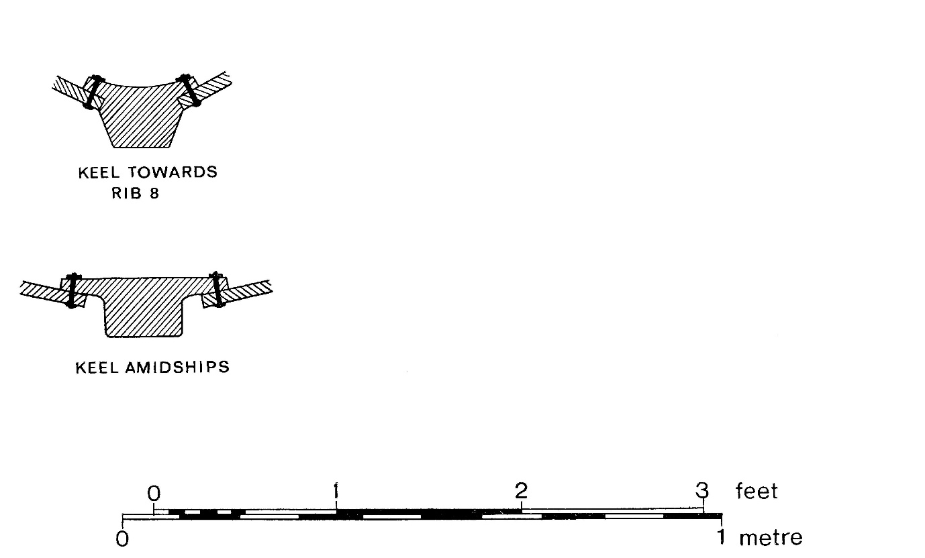©Trustees of the British Museum

Page 381, at the bottom, talks of a note on Science Museum (1939) which mentions a 5½ in. deep impression under the keel beneath rib 10. This is a red herring – the note actually refers to the depth of the bottom of the rib.

Note on the keel scarfs
Based on evidence discussed in Evans (1975, Chapter V) Section 5: The scarfs and their position (starting p. 392), fig. 325 gives the position of the three rivets used for the scarf where the stern post was attached, just forward of rib 21. It also shows where it believes the scarf joint to the stem was located, using three hypothetical treenails just aft of rib 5. From these positions the implied length of the keel is about 48 feet overall, including the scarfs.
The story of how and where the stem and stern were scarfed to the keel is quite complicated, and there are other possibilities for the length and nature of the keel. From p. 398: ‘To summarise: the alternatives are: (1) a single scarf between ribs 21 and 20 and ribs 5 and 6 (giving a flat keel with a length of 46 ft. [12 m]); (2) a single scarf between ribs 22 and 23 and ribs 3 and 4, giving a keel with a substantial curve at each end and a total length of 57 ft. [17.4 m]; (3) a double scarf with a lower join at ribs 21 and 6 and an upper join near ribs 23 and 3.’

Depth of the keel
For support that the keel need not be that deep, Evans (1975, p. 378) says ‘Also, the fact that the Graveney boat has a flat keel-plank has removed many of the doubts about the viability of an apparently weak keel … (Evans and Fenwick, 1971)’. This reference states (p.94) that the boat is second half of the ninth century and that ‘Lack of a projecting keel may signify no more than a requirement to sail in shallow waters or use tidal havens.’
Similar views are expressed on p. 261, in relation to the Nydam and Kvalsund ships when compared to Viking ships.
Against that, Goodburn (2019) cautions that deeper keels have been found on many similar medieval vessels, and that the amount of compression that timber suffers varies unpredictably with various soil types.
In any reconstruction, there is the practical consideration that some keel projection beyond the bottom of the garboard strakes provides some useful protection when the vessel beaches or goes aground.

Does Volume 1 imply a two-component keel plank?
Discussing the keel, Evans (1975, Chapter V, p. 378, p. 381) uses the word ‘hog’ five times.
Two definitions of ‘hog’ from the internet are:
- A structural board installed on top of the keel to help attach the garboard plank.
- The primary main structural longitudinal member fitted immediately above the keel and running from the forward to the after deadwood. The inner edges of the garboard strakes are attached to the outer edges of the hog.
So it could be taken that Volume I is implying a two-component keel.
However, the first mention of ‘hog’, at the top of p. 378 uses scare quotes. When used at the top of p. 381, there is a footnote to say the word is referring to ‘the flat upper surface of the keel-plank’. The next two mentions put the word inside scare quotes. The final mention is the slightly problematic one, as the ‘hog’ is missing any quotes, and it might be interpreted to have become something solid and separate.
All the same, if there had been serious thoughts about a two-component keel-plank it would have been odd not to mention them on p. 375 at the beginning of Section 3 : The keel. Also figs. 290, 291 and 292 all show the section of the bottom structural member as one piece. Finally, if you are starting with half of a tree-trunk it would seem more natural to keep it all in one piece.

Conclusions
Evans (1975) and Bruce-Mitford (1975), suggests a size and shape for a single-component keel, subject to much discussion of the archaeological difficulties encountered and how to interpret them. The picture is internally consistent and agrees with the limited interpretations from 1939. These conclusions can be taken at face value as a good effort, but there is much scope for uncertainty.
The sizes and shapes themselves are covered in section 3.2 above.

History

Status | Date | Author | Details of change
Published for Symposium. | 6/10/18 | Paul Constantine  Joe Startin | Published after three drafts
Draft 0.1 | 22/2/19 | Joe Startin | Added History section
Issue 1.0 | 6/3/19 | Joe Startin | Added Section 3.3 concerning depth of keel.
Draft 1.1 | 6/10/19 | Joe Startin | Mentioned 1939 section at rib 9 in section 2.  Enlarged on sections H and I in section 3.2  Added point about keel projection in section 3.3
Draft 1.2 | 16/4/20 | Joe Startin | Added copyright notice at beginning.
Draft 1.3 | 21/12/20 | Joe Startin | Added references for Philips and Science Museum. Added information from Science Museum (1939) to section 2.
Draft 1.4 |  | Joe Startin | Followed Evans (19750 in italicisation of a line from Philips in section 2. Shifted Fig 290 interpretation from section 2 to section 3. Information on keel plank compression and a couple more of the sections taken added to 3.1. In section 3.2, added a note on ‘red herring’ introduced on p.381. In Conclusions, added ‘ much scope for uncertainty.’

References

BRUCE-MITFORD, R., 1975. The Sutton Hoo Ship Burial, Volume I. London. British Museum

EVANS A. C., 1975. The Ship. In: BRUCE-MITFORD R. (ed.), 1975. The Sutton Hoo Ship Burial, Volume I. London. British Museum, 353-413

EVANS, A. C., FENWICK, V.H., 1971, The Graveney boat. Antiquity, XLV, Cambridge 1971, 89-96

GOODBURN, D., 2019. Private communication

PHILLIPS, C. W., 1940a. The Excavation of the Sutton Hoo Ship Burial, The Antiquaries Journal, XX (2), 149-202
SCIENCE MUSEUM, 1939. Drawing No 2012/B, Provisional Drawing, 2 Sheets, Sheet 2. Colchester and Ipswich Museum

