Anglo-Saxon Felling and Chopping Axes: a summary of the research and archaeological evidence

Alec Newland

Document SHSC034, Issue 1.0

The Sutton Hoo Ship’s Company, The Longshed, Tidemill Way, Woodbridge, IP12 1FP
Email: alec@saxonship.org
Website: www.saxonship.org

Copyright © 2021 The Sutton Hoo Ship’s Company. Permission granted to reproduce for personal and educational use only. Commercial copying, hiring, lending is prohibited.

Abstract: The Sutton Hoo Longship was likely constructed between the late 6th century and the early 7th century. While researching tools used during this period in order to create replicas for use in the reconstruction of the ship, the felling or chopping axe was identified as a necessary tool. This paper summarises the research and archaeological evidence for Anglo-Saxon chopping axes. These axes would generally have been between 500-1000g in weight, with rounded or single-stepped lugs below the eye and either a symmetrically flared blade or a blade with a straight upper edge and flared lower edge. Head lengths are around 160-185mm with blade lengths ranging from 52 to 85mm resulting in length to blade ratios of 3:1 or 2:1. Axes of these forms would be good candidates for use in the reconstruction of the Sutton Hoo Longship.

Keywords: Axe, Woodworking, Shipbuilding, Anglo-Saxon, Merovingian

Introduction
The reconstruction of the ship found in Mound 1 at Sutton Hoo aims to use tools which were present or plausibly present during the construction of the original ship, probably somewhere between the late 6th century and the early 7th century (an estimation based on the ship’s burial date in the early 7th century (Bruce-Mitford, 1975), and the lifespan of reconstructed Viking ships (Sørensen and Rodevad Dael, 2020)).
Timbers used in the construction of clinker-built ships must be felled and roughed out before finishing. Tool marks and material evidence for large saws used in woodworking are non-existent in Early Anglo-Saxon archaeology (D. Goodburn 2019, pers. comm.). Therefore, Anglo-Saxon shipbuilders likely used axes for felling trees and roughing out timber ready for hewing and finishing. Felling or chopping axes of the period were a general-purpose tool, likely used not just for shipbuilding but, depending on the wielder, for a range of woodworking tasks including forest management, firewood processing, building timber structures and carving smaller wooden objects. The Bayeux Tapestry provides historical evidence for felling axes used specifically by Anglo-Norman shipwrights before hewing planks with T-shaped axes (Stenton, 1957).
The general shape of the felling or chopping axe appears little changed from the Roman Iron Age into the Early Medieval period. Indeed, many Anglo-Saxon axes identified as chopping axes are not dissimilar to some of those deposited with the ship at Nydam, Denmark in the Migration period (Engelhardt, 1866: pl. XV) (Fig. 1). This paper summarises the evidence for different forms of Anglo-Saxon chopping axe and their use in Anglo-Saxon woodworking.
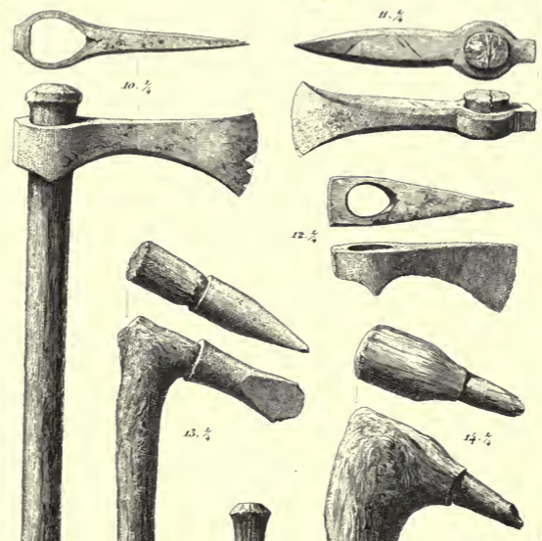
Figure 1. Migration period axes and other woodworking tools found at Nydam (Engelhardt, 1866; pl. XV).

Anatomy of an axe

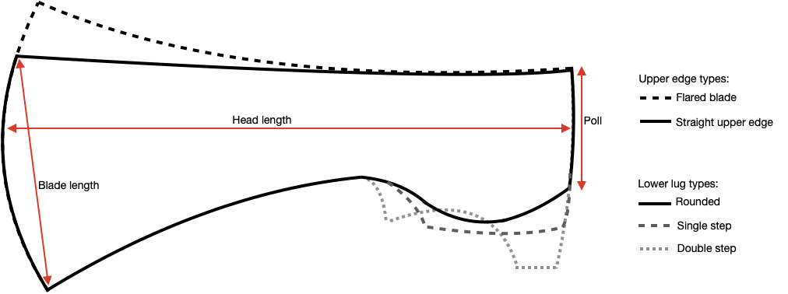
Figure 2. Profiles and terminology of Anglo-Saxon chopping axe types (except for the double-stepped lug, which is Merovingian in origin and occurs on some 6th century Anglo-Saxon franciscas and T-shaped war axes).

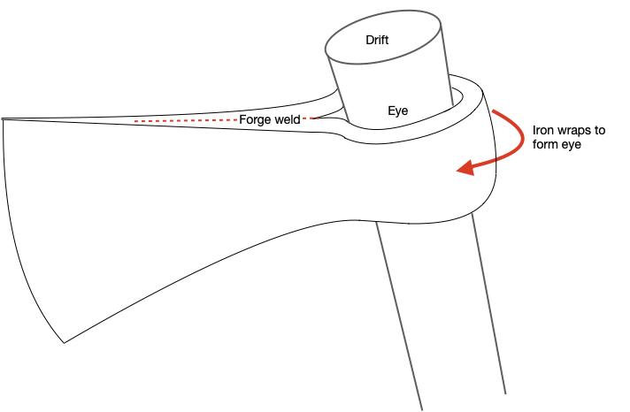
Figure 3. ‘Wrap-around’ method of forging an axe eye, where the iron is wrapped around the drift to form the eye and forge-welded together, forming the characteristic forge weld line and crease just in front of the eye.

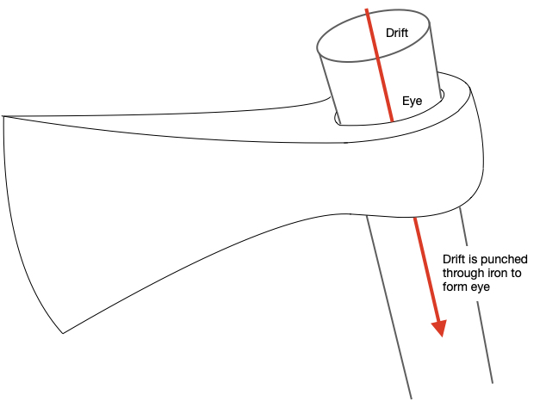
Figure 4. ‘Drifted’ method of forging an axe eye, where the drifted is punched through the iron to form the eye.

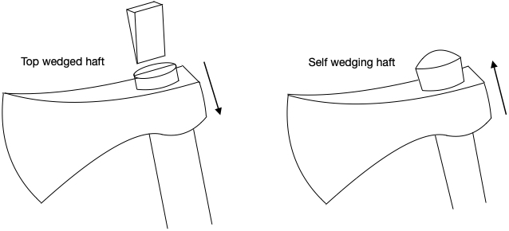
Figure 5. Methods of hafting an axe head. Top wedged: Head fitted from the top of haft and is held in place with a wedge. Self-wedging: Head fitted from the bottom of haft and wedges itself as the haft widens near the top.

Archaeological evidence

Anglo-Saxon felling and chopping axes
The best-documented Anglo-Saxon woodworking axes come from the excavations at Flixborough, Lincolnshire. Along with several T-shaped finishing axes, two of the more ‘traditional’ shape were found. The first was found within a settlement, stratigraphically dated late 7th to early 8th century (Evans and Loveluck 2009: 253-255, fig. 7.1) (Fig. 6). Its eye appears to have been forged with a ‘wrap-around’ technique (Fig. 3). The socket is 43mm wide and is pinched at the base, suggesting a self-wedging haft like that of the Nydam axe haft (Engelhardt, 1866: pl. XV, no. 10) (Figs. 1, 5). Traces of wood were found in the eye, likely of beech (Fagus sylvatica). Ash (Fraxinus excelsior) may also have been used as another species well-suited for tool handles. The length of the axe is 160mm with a blade length of 85mm; a ca. 2:1 ratio common in Anglo-Saxon axes (Evans and Loveluck 2009: 253).
The size, flared blade and (albeit crudely) stepped lower lug are reminiscent of the 7th century Merovingian war or ceremonial axe from the Neuweider-Becken area, Germany (Marzinzik, 2013). Despite their similarity and rough contemporaneity, these axes likely had very different purposes; the Neuweider-Becken axe being lavishly decorated with inlaid silver wire. The more refined (and more obviously intentional) double stepped lugs of the Neuweider-Becken axe (Fig. 2) is evidently a tradition borrowed from the francisca; a style of war axe of Merovingian origin, but also common in 6th century Anglo-Saxon weapon burials across Southern England, including Mound 3 at Sutton Hoo (Bruce-Mitford, 1975: 126).
Axes with symmetrically flared blades are depicted in the Bayeux tapestry, used by foresters to fell trees specifically for shipbuilding (Stenton, 1957). Flared axe blades are also found in 6th century Anglo-Saxon burials (Hirst and Clark, 2009; Hollingworth and O’Reilly, 1925), but these have a flared poll common in continental Merovingian war axes. The similarities between war and wood-working axes during the period highlights the importance of caution and attention to detail when interpreting axe finds as weapons or tools in all but the most obvious cases. Parallels for this flared blade can also be found in Scandinavia, especially the two axes found with the Oseberg ship buried in the 9th century (Christensen, 2008: fig. 3). With one head weighing ca. 1000g, these are also interpreted as felling axes and their intact hafts give a rare indication of handle lengths during the period; measuring 715mm and 785mm in length (V. Vike 2021, pers.comm.). Like the Flixborough axe, these hafts were self-wedging (Fig. 5).

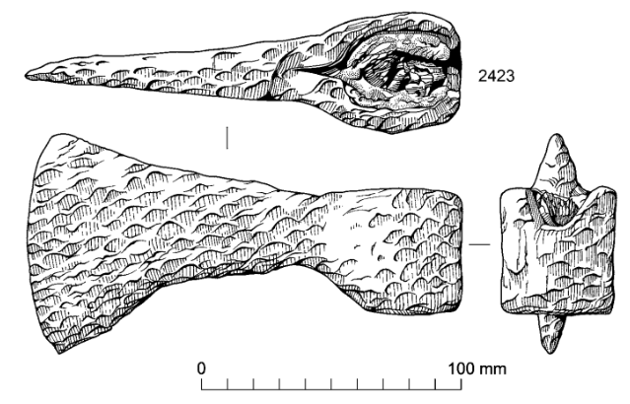
Figure 6. Late 7th to early 8th century Anglo-Saxon chopping axe from Flixborough, Lincolnshire.

The second axe from Flixborough was found in a hoard with the T-shaped axes, generally dated to the Middle or Late Anglo-Saxon period (Evans and Loveluck 2009: 256, fig. 7.5) (Fig. 7). At first glance, this appears to be a narrow but robust felling axe, with a wedge-shaped cross-section and a drifted eye (Fig. 4) (as opposed to a ‘wrap-around’ eye). However, this axe is asymmetric; one face runs parallel to the eye whereas the other slants to meet it. In other words, this axe is ‘sided’, with one flat working side capable of producing a flat, smooth finish on timber in a similar way to the Flixborough T-shaped axes. With a length of 185mm and blade length of 57mm, its ratio is ca. 3:1. The relatively narrow blade may indicate suitable use as a ‘chisel axe’ for cutting mortises in timber or even shaping the rabbet of a T-shaped keel, such as that in the Sutton Hoo ship. The ‘mushroomed’ poll indicates use with a hammer, which supports this interpretation.

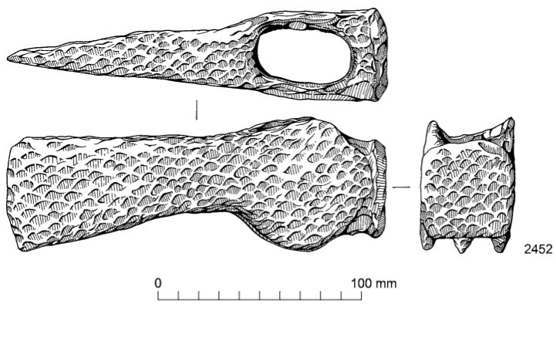
Figure 7. Middle to Late Anglo-Saxon ‘sided’ axe from Flixborough, Lincolnshire.

Other Anglo-Saxon axes interpreted as felling or chopping axes include that from the 9th-10th century Hurbuck hoard (Hodges, 1905), and two listed under ‘axe’ or ‘axehead’ in the Portable Antiquities Scheme (PAS) database, from Winteringham, North Lincolnshire and dated to the Early Medieval period. The Hurbuck axe has a narrow, symmetrically flared blade, with an apparent length to blade ratio of 3:1 while the two PAS axes have a straight upper edge and flared lower edge (Fig. 2) and a ‘wrap-around’ eye (Fig. 3). Both the PAS axes weigh ca. 500g. They are 165mm and 182mm long with blade lengths of 56mm and 52mm respectively, resulting in a narrow blade with a ratio of 3:1 similar to the Flixborough hoard axe. However, these axes appear to be symmetrical in cross-section. These axes resemble the hafted axe from Nydam (Engelhardt, 1866: pl. XV, no. 10) with the exception of more rounded single lugs. This is a form known as Type I in Wheeler’s original typology (Wheeler, 1927), based on Early Medieval finds from the river Thames and applied to both tool and war axes.

The evidence for bearded axes
There appears to be little evidence for bearded axes in Early Anglo-Saxon England. However, bearded axes have been found in contemporary Merovingian and Suebian contexts (respectively Cologne and Heidelberg, Germany).
Bearded axes were also present in the Vendel period culture of Sweden, as evidenced by Vendel helmet pressblech iconography and the axe found in Vendel grave I (Arbman, 1980: 26; Lundström, 1980: 34). The bearded axes of the Mästermyr hoard from Sweden are dated to the Viking Age, but attest to bearded axes being used for carpentry in Scandinavia concurrently with the Early Medieval period in England. It is also notable that the narrow bladed Mästermyr axe appears to be asymmetrical or ‘sided’ like the Flixborough hoard axe (Arwidsson and Berg, 1999: pl 26, no. 61) suggesting a similar purpose for finishing timbers.

The Sutton Hoo axe-hammer
Finally, the enigmatic axe-hammer from Sutton Hoo mound 1 must be addressed. This axe has been tentatively interpreted in the past both as a weapon and as a tool for shipbuilding (Dobat, 2006). However, the estimated original weight of the axe, with its solid iron shaft, is 3kg; a weight which would likely be impractical for both uses. The most recent and convincing interpretation for the axe-hammer’s use is that as a tool for animal sacrifice and therefore a symbol of a chieftain’s priestly role in Germanic pagan society (ibid.).

Conclusion
Based on the evidence above, the axes used for felling and chopping timber during the Anglo-Saxon period would generally have been between 500-1000g in weight, with rounded or single-stepped lugs below the eye and either a symmetrically flared blade or a blade with a straight upper edge and flared lower edge (Fig. 2). Head lengths appear to be fairly consistent around 160-185mm with blade lengths ranging from 52 to 85mm, resulting in length to blade ratios of 3:1 or 2:1. There is evidence for both ‘wrap-around’ and ‘drifted’ eye forging techniques, and the presence of both tapered and straight eyes provide the possibility for self-wedging and top-wedged hafts respectively (Fig. 5). That said, the intact hafts that have been found suggest a preference for self-wedging hafts. Existing hafts have been made of beech (Fagus sylvatica). Hafts may have been ca. 700-800mm in length which, although based on singular evidence, aligns with 19th century forest axe hafts. Unless directly contemporary evidence to the contrary is found, replica axes following the characteristics and forms described above would be good candidates for use in felling and chopping during the reconstruction of the Sutton Hoo Longship.

History

Status | Date | Author | Details of change
Draft 0.1 | 26/03/21 | Alec Newland | First Draft
Issue 1.0 | 05/08/21 | Alec Newland | Second draft, subsequently updated according to comments by peer review led by Kasandra Boguslawska. Changed terminology, added descriptions of axe use, added ‘Anatomy of an axe’ section, minor changes and formatting.

References

Arbman, H., 1980. ‘Båtgravarna I Vendel’ in Sandwall, A., Vendeltid. Stockholm: Statens Historiska Museum, pp. 26.
Arwidsson, G., and Berg G., 1999. The Mästermyr Find. A Viking Age Tool Chest from Gotland.
Bruce-Mitford, R., 1975. The Sutton Hoo Ship-Burial. Volume I: Excavations, Background, The Ship, Dating and Inventory. Cambridge: British Museum Publications Ltd, pp. 126.
Christensen, A.E., 2008. Recreating Two Early-Norse Tool Chests, IJNA 37(1), pp. 177-184
Dobat, A.S., 2006. The king and his cult: The axe-hammer from Sutton Hoo and its implications for the concept of sacral leadership in Early Medieval Europe. Antiquity 80, pp. 880-893.
Evans, D.H. and Loveluck, C., 2009. Life and Economy at Early Medieval Flixborough. Oxford: Oxbow Books, pp. 253-260.
Engelhardt, C., 1866. Denmark in the Early Iron Age. London: Williams and Norgate, pl. XV
Hirst, S. and Clark, D., 2009. Excavations at Mucking. The Anglo-Saxon Cemeteries. London: MOLA, fig. 209.1; pp. 401.
Hodges, C. C., 1905. ‘Anglo-Saxon remains’ in Victoria County History of Durham I. London, pp. 211-240.
Hollingworth E.J. and O’Reilly M.M., 1925. The Anglo-Saxon Cemetery at Girton College, Cambridge: A Report Based on the MS. Notes of the Excavations Made by the Late F. J. H. Jenkinson M.A. New York: Cambridge University Press.
Lundström A., 1980. ‘Gravgåvorna Vendel’ in Sandwall, A., Vendeltid. Stockholm: Statens Historiska Museum, pp. 34.
Marzinzik, S., 2013. Masterpieces of Early Medieval Art. London: British Museum Press.
Portable Antiquities Scheme: www.finds.org.uk [Accessed 12/03/2021].
Stenton, F., 1957. The Bayeux Tapestry (London).
Sørensen, T. and Rodevad Dael, M., 2020. Roar Edge: The Lifecycle of a Reconstructed Viking Ship. EXARC Journal 2020 2.
Wheeler, M., 1927. London and the Vikings, London Museum Catalogues: No. 1. London.

